**Programming with B4X**

Brief Theory

Version 1.0, February 2021

[](https://creativecommons.org/licenses/by/4.0/)

Table of Contents

Lesson 1 – Why B4X? 1

Installing B4X 1

Lesson 2 – The meaning of the problem 2

The concept of the problem 2

Understanding the problem 2

Searching for a solution or set of solutions. 2

Choosing the right solution 3

Implementing the solution 3

Checking whether this solution had the desired results. 3

Lesson 3 - My first Program 4

Hello World 4

Recommended instructions for the instructor 4

Exercises 5

Lesson 4 - Variables and Range 6

How to find how many variables you need 7

Naming Variables 8

Declaring Variables 8

My First Variable 8

Comments 9

The log area and the log function. 9

Mathematical Operators 10

Strings 11

Exercises 12

Lesson 5 – Designer 15

First steps with design 16

Visual designer 17

The Views Tree 18

Properties 18

Abstract Designer 18

Example 1 18

Decide on the size of the app screen. 18

Set an appropriate variant. 19

Design a wireframe. 19

Create the views. 19

Excercises 22

Lesson 6 – From Designer to Code 23

Class_Globals 23

A deeper look at the use of variables. 24

Passing Values to Code 24

Events 25

Writing code in Event 26

Properties 27

Exercises 28

Lesson 7 – Conditional Statements 29

Logical Variables 29

Comparative Operators 29

Logical Operators 30

Logical operators in programming 31

Examples of evaluation of logical sentences. 31

If command 32

If – Else 33

If – else - else if 33

Algorithms with if 36

Exercises 36

Lesson 8 – Subroutines 39

Create a subprogram in B4J 39

Example 1 39

The memory of the subprogram in B4X 41

Return a value from a subprogram. 42

Example 2 42

Exercises 43

Lesson 9 – Classes 45

Classes 45

Example of class in B4J 46

Implementation methodology 46

Insert a book. 47

Show Book Items. 48

Change book items. 48

The Initialize subprogram. 48

Use Class 48

Use of methods 49

Exercises 49

Lesson 10 – B4XPages 51

The structure of an application's folders 51

Starting an application with B4XPage. 52

What is Root 52

Create a new B4XPage 53

Call a new B4Xpage. 55

Close a B4XPage. 56

Transfer information between pages 57

The Life of B4XPages 58

Exercises 59

# Lesson 1 – Why B4X?

**1h**

Many new developers wonder in which programming language to invest their time and effort. Each programming language has advantages but also disadvantages that should be considered. Often the selection of a language also determines the subsequent evolution of the developer. Even more, when it comes to using language for educational purposes, there are individual elements that need to be considered.

So, the programming language must be:

* Modern and structured
* Be easy to learn for kids and new programmers.
* Provide an integrated development environment without confusing.
* To be able for the student to develop applications on different platforms like Windows, Android, IOS, Linux, Raspberry Pi, Arduino etc.
* Provide all modern data structures as lists, maps etc.
* To keep students interested by providing the possibility of developing different types of applications for example games etc.

The **B4X** programming language provides all the above features and is also a language for developing high-level applications which can be a springboard for future professional development. In addition, it has a very enthusiastic audience that gladly help in any kind of question.

For more information and material you can visit the website at [https://www.](https://www.b4x.com/learn.html) [b4x.](https://www.b4x.com/learn.html) [com/learn.](https://www.b4x.com/learn.html) [html](https://www.b4x.com/learn.html)

## Installing B4X

The most updated information about installing will always be here: <https://www.b4x.com/b4j.html>

# Lesson 2 – The meaning of the problem

* What is a problem?
* What is data?
* What is information?
* What steps need to be taken to resolve a problem.
* What is algorithm.

What students should know

**1h**

## The concept of the problem

Every day in our lives we have problems. Simple problems of everyday life and often even bigger. As a problem we usually define a situation that we are experiencing and which makes it difficult for us to deal with it or solve (Cambridge, 2021).

When we are thinking about a problem these are steps become unconscious in our minds:

* Understanding the problem
* Searching for a solution or set of solutions.
* Choosing the right solution
* Implementing the solution
* Checking whether this solution had the desired results.

### Understanding the problem

Understanding the problem is the first step in designing and solving a problem. It is a particularly critical stage because this will also affect the development of the solution. Includes the following steps:

1. Description of the problem

The description of the problem is usually done by ourselves or someone who has it. In this step it is important to clarify all its 'dark' points and to have no doubt as to its wording.

1. Find the data.

Finding the data means what these elements are based on in order to solve a problem, for example in an equation ax + b = 0 data are the factors a and b.

1. Find the requested.

The information that we need to find to deal with the problem. Continuing the previous example information is the x of the equation ax+b=0.

### Searching for a solution or set of solutions.

Once we have recognised the data and what is requested, a solution must be found to solve the problem. Often that's not easy. Thus, it is necessary to look for a method or **a logical set of steps leading to the solution**. These steps must lead to a solution **whenever** the same problem arises and, moreover, be done in **a relatively short period** of time.

**In mathematics and computer science, an algorithm is a finite sequence of well-defined, computer-implementable instructions, typically to solve a class of problems or to perform a computation.**

### Choosing the right solution

Often a problem can have more than one solution or some of them may be more efficient than others. Choosing the solution correctly leads to a shorter and more reliable outcome.

### Implementing the solution

After the resolution method is selected, a series of actions must be taken to implement it. In other words, apply **the Algorithm.**

### Checking whether this solution had the desired results.

Finally, after applying the solution it is necessary to test with various data, to examine whether it leads to correct results each time it is performed without problematic situations.

Picture 1 The steps

# Lesson 3 - My first Program

**2h**

* How to start B4J
* How to create and save a new project
* How to run a project
* What is error screen.
* How to see Turtle commands
* How to write a new project using Turtle

What students should know

## Hello World

Make a program that draws a straight line with the help of the turtle on the computer screen.

## Recommended instructions for the instructor

The aim of the above exercise is to familiarize students in the creation of a project with B4J and to become the first acquaintance with the programming environment. The following instructions in no way limit the instructor to adapting his course to the relevant educational conditions.

**Teachers tip**

This is students first lesson. Therefore, keep it simple!



| **Function** | | **Description** |
| --- | --- | --- |
| **1** | How to create a first project with B4J | *Menu File -> New -> B4Xturtle*  *Project Folder*  *Project Name*  Explain to students the importance of the right names in each project they create and the value of correct storage in folders in a structured way |
| **2** | Run Project | *Menu Project -> Compile & Run*  Explain what means compile and how to recognize syntax errors in log. You don’t need to provide to much information about compilation. Just the basic stuff in order to run a project. |
| **3** | #Region Project Attributes | Change Values in *MainFormWidth* and *MainFormHeight* to make different size application |
| **4** | Sub Turtle_Start | *What means Sub?*  A small amount of code which is doing a certain activity. |
| **5** | Turtle methods | What is Turtle?  What .MoveForward do?  How can we find more commands?  (Tell students to write “Turtle.” To see the list of methods. |
| **6** | Errors | How to identify an error in log screen |

## Exercises

1. Using turtle and methods ***MoveForward****,* ***TurnLeft****,* ***TurnRight***draw a square with any size you want.
2. Using Previous commands and ***PenUp****,* ***PenDown***and***Move***draw 3 squares like the image bellow.
3. Using previous commands design a sketch of your choice. Give a name to your sketch and explain how you did it.

# Lesson 4 - Variables and Range

* Explain how a computer stores data in ram.
* Explain what a variable is.
* How to name a variable
* Assign a value to a variable.
* Use Mathematical Operators
* Use log command to display a variable value
* What is a string.

What students should know

**3h**

Imagine that you live on a street with a few million houses all in a row; each house has as you all know its address which starts at number 1 and ends at the last house; in order to be able to locate a friend who lives on that street you need to know the number of the house; so we have on the one hand a house number and on the other the friend who lives in that house. 

Figure 1 Computer Memory (https://www.freepik.com)

The computer's central memory works in much the same way. There are many houses each with its address and a "resident" within each house. This address is called memory address and the "resident" content. On the computer often the "resident" who from now on we will call variable needs more houses to fit.

For a programmer to use memory, he must know the data he needs and the type of data. These can be integers or real numbers, words or letters, some reasonable values (truth, false). He also needs a “home” in the computer memory to store them represented by address.

In B4X the data can be stored in different types as:

|  |  |
| --- | --- |
| **B4X** | **Type** |
| Boolean | boolean |
| Byte | integer 8 bits |
| Short | integer 16 bits |
| Int | integer 32 bits |
| Long | long integer 64 bits |
| Float | floating point number 32 bits |
| Double | double precision number 64 bits |
| Char | character |
| String | array of characters |

Table 1- Simple types of variables

Every type needs different space in memory to store values.

Because it is difficult for the developer to remember all the addresses of his data, each address corresponds to a name. Fortunately, in fact this is done by the programming language itself and all it takes is to think of a good name for his data. For example, a data that is an integer for age could be called “age”. Now, there is a “home” called age in computer memory.

**Remember**

Variables are used to store information to be referenced and manipulated in a computer program. They also provide a way of labeling data with a descriptive name, so our programs can be understood more clearly by the reader and ourselves. It is helpful to think of variables as containers that hold information.

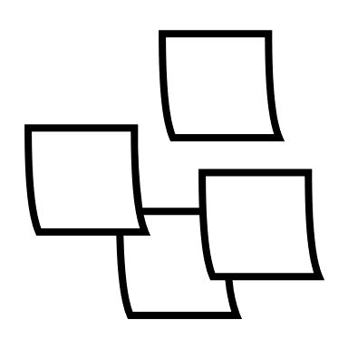

## How to find how many variables you need

In any programming problem that a developer encounters, they should be able to locate the data and the information’s of the problem.

In programming we name all those elements that we need to know to move forward in solving a problem. Usually in a programming problem we find them in the pronunciation of the exercise with the help of keywords such as:

* Reads
* Registers
* Ask
* Accept
* Type

*Example 1: Write a program that converts the euros we type into dollars.*

*Example 2: Make a program that accepts a positive integer and calculates its square, cube, and square root.*

Information’s

Information’s in programming are all the elements that we need to calculate after processing our data. We usually find them in pronunciation using keywords such as:

* Calculates
* Displays
* Writes
* Counts
* Convert

In the previous examples what are the requested?

## Naming Variables

The names of the variables in B4X must follow specific rules.

* They must start with a capital or small character.
* They can then have digits or the character underscore.
* B4X does not distinguish capital and small letters.

Also, it’s a good practice to name variables beginning with 3 small letters indicating the kind of a variable and continue with 1 uppercase letter and a meaningful word. For example:

* Dim **intAge** as Int
* Dim **fltAmount** as Float
* Dim **strName** as String

This practice helps a lot when you find variables in the code to recognize the type and the value it stores.

## Declaring Variables

### My First Variable

Make a program that assigns a value into integer and then draws with the help of the turtle a line of length as long as the value in the variable.

In B4X to use a variable we must first inform the language of its existence in order to commit space in the computer's memory to store its value.

For example, in the following code, the statement is as follows:

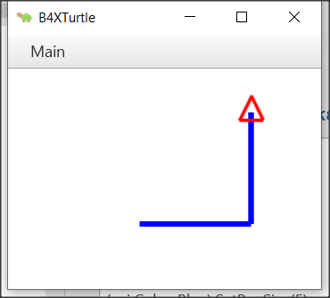‘Program: My First Variable

Sub Turtle_Start

Private intDistance As Int

Public intTurn As Int

intDistance = 100

intTurn = 90

Turtle.SetPenColor(xui.Color_Blue).SetPenSize(5)

Turtle.MoveForward(intDistance)

Turtle.TurnLeft(intTurn)

Turtle.MoveForward(intDistance)

End Sub

The declaration of variables begins with the keyword Private or Public.

Private means that the variable is known only in the specific space declared and no other program or subprogram does not know its existence and thus the value it contains.

Instead, a variable statement that starts with the keyword Public can be known to other programs or subprograms or classes etc.

After the keyword Private or Public follows the name of the variable we chose to give. This is where the rules discussed above apply. Finally, the type of the variable follows. For simple variables these are all those described in the *Table 1- Simple types of variables*.

**Teachers tip**

You don't have to explain all the variables already as well as their use. For your students to start programming, the basics of integer, float, string are enough. As you progress through the courses you can include other types according to your needs.



## Comments

In computer programming, a comment is a programmer-readable explanation or annotation in the source code of a computer program. They are added with the purpose of making the source code easier for humans to understand and are generally ignored by compilers and interpreters. The syntax of comments in various programming languages varies considerably. (Wikipedia, 2021)

In B4X comments are inserted by writing the character ' as their first letter. From this point on it is not recognized by the translator of the language. Generally, in B4X comments you should put anywhere it is important to remember what you are doing as well as before the subprograms to explain what their job is. Comments are easily distinguished in code from the green color given to them by the programming environment (IDE).

Example

‘Program: My First Variable

‘This program draws a right angle, with sides as much as the   
‘value of the intDistance variable

Sub Turtle_Start

Private intDistance As Int

Public intTurn As Int

intDistance = 100 ‘The sides of the right angle

intTurn = 90 ‘90o angle

Turtle.SetPenColor(xui.Color_Blue).SetPenSize(5)

Turtle.MoveForward(intDistance)

Turtle.TurnLeft(intTurn)

Turtle.MoveForward(intDistance)

End Sub

## The log area and the log function.

During programming various errors occur. Generally, errors in programming are divided into two categories syntax and logical. For now, we will deal with the syntax errors that are recognized by the programming language and indicate them on the logs screen. In order to access the logs screen we need to click on the relevant logs tab at the bottom right. The Logs screen itself is divided into two frames, the first of which displays errors and the bottom screen displays language messages or that information we want to display using the log() function. Using the Log() function helps the developer display messages while running a program as well as variable values to help control the program's proper operation.

Figure Logs Screen

To display any information on the screen it is sufficient to use the log() function as the example of the following image.

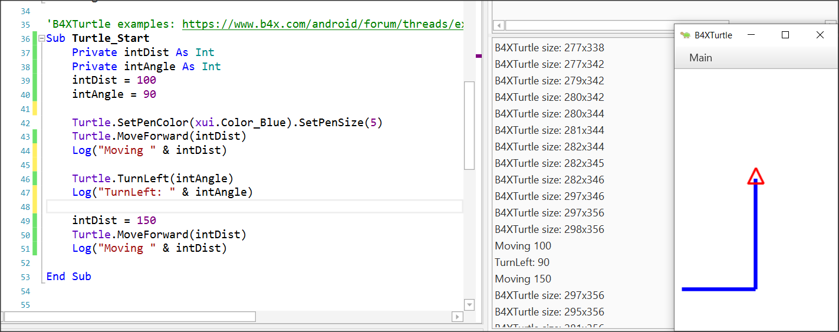

Figure 3 Using log function

## Mathematical Operators

B4X supports all known mathematical operations:

|  |  |  |
| --- | --- | --- |
| **Operator** | **Example** | **Operation** |
| + | x + y | Addition |
| - | x - y | Subtraction |
| * | x * y | Multiplication |
| / | x / y | Division |
| Mod | x Mod y | Modulo |
| Power | Power(x,y) xy | Power of |

Examples:

Private intA, intB, intC, intS As Int

Private fltD, fltM As Float

intA = 40

intB = 20

intC = 30

intS = intA + intB + intC

Log(intS) ‘Shows 90

fltD = intS / 3

Log(fltD) ‘Shows 30

intA = intAa + 1 ‘Increase intA by 1

Log(intA) ‘Shows 41

intS = Power(intA – 11, 2) ‘ 302

Log(intS) ‘Shows 900

fltM = intA mod 2 ‘41 modulo 2

Log(fltM) ‘Shows 1

## Strings

In computer programming, a string is traditionally a sequence of characters, either as a literal constant or as variable. The latter may allow its elements to be mutated and the length changed, or it may be fixed (after creation) (Wikipedia, Wikipedia - Strings, 2021).

A string is declared like the other variables using the String statement.

Private strName as String

Assigning value to a string can be done with the = symbol or by reading a value from the user (something we'll see later).

Private strName, strSurName as String

strName = “George”

strSurName = “Smith”

Also we can string together using the character &.

Private strName, strSurName as String

strName = “George”

strSurName = “Smith”

Private strPerson as String

strPerson = strName & “ “ & strSurName

log(strPerson) ‘ shows George Smith in log screen

Private strName2 as String

strName2 = “John”

strName2 = strName2 & “ Smith”

The are also a lot of functions regarding strings that makes our life easier when we are dealing with them:

|  |  |
| --- | --- |
| **CharAt**(Index) | Returns the character at the given index. |
| **CompareTo**(Other) | Lexicographically compares the string with the Other string. |
| **Contains**(SearchFor) | Tests whether the string contains the given SearchFor string. |
| **EndsWith**(Suffix) | Returns True if the string ends with the given Suffix substring. |
| **EqualsIgnoreCase**(Other) | Returns True if both strings are equal ignoring their case. |
| **Length** | Returns the length, number of characters, of the string. |
| **Replace**(Target, Replacement) | Returns a new string resulting from the replacement of all the occurrences of Target with Replacement. |
| **StartsWith**(Prefix) | Returns True if this string starts with the given Prefix. |
| **ToLowerCase** | Returns a new string which is the result of lower casing this string. |
| **ToUpperCase** | Returns a new string which is the result of upper casing this string. |
| **Trim** | Returns a copy of the original string without any leading or trailing white spaces. |

Table 2 String Functions (https://www.b4x.com/android/documentation.html)

**Teachers tip**

You can find more information about string manipulation in language booklets at (<https://www.b4x.com/android/documentation.html>)



## Exercises

1. In the following exercises, identify the variables you need to declare. For each of them, write the relevant statement and give it an appropriate name.
   * Calculate the volume of a cylinder with a radius of one metre and a height of two metres.
   * Make a program that accepts a positive integer and calculates its square, cube, and square root.
   * Make a program that reads a sum of money in € and calculates and displays the corresponding amount in $.
   * Write a program that reads the length of the sides of a rectangle from the keyboard and calculates and displays its area.
   * The total resistance R of two resistances R1 and R2 connected in series is R1 + R2 and parallel (R1*R2)/(R1+R2) respectively. Male a program that it reads two values of resistant R1 and R2 and calculates the total resistance in series and parallel.
2. In the following variable names, select which are correct and which are not:

intAge

|  |  |  |
| --- | --- | --- |
| **Name** | **True** | **False** |
| int Age | □ | □ |
| _fltAmount | □ | □ |
| strName | □ | □ |
| 1myAge | □ | □ |
| int_value | □ | □ |

1. It's the end of the semester and you got your grades from three classes: Geometry, Algebra, and Physics. Create a program that: gives in 3 variables the grades of these 3 classes (Grades range from 0 - 10) Calculate the average of your grades.
2. You have bought a Bitcoin and now it's on the rise!!! Create a program that:

* Assign the value of the bitcoin at the time of purchase.
* Assign the percentage of increase (or decrease)
* Logs the total value of your bitcoin.
* Logs the increase or decrease value.

1. You now own some property, and you want to calculate the total area of the property. Create a program that:
   * Assign the width and height in two variables.
   * Calculate and log the area.
2. You are interested in buying a new laptop. You check the price and you see that the price is 300$ without the 10% tax. Create a program that:
   * Assign the the price of the laptop in a variable.
   * Assign the tax percentage in a second variable.
   * Calculate and logs the total amount.
3. In a company the monthly salary of an employee is calculated by the minimum wage 400$ per month, plus 20$ multiplied by the number of years employed, plus 30$ for each child they have. Create a program that:
   * Assign the number of years employed in a variable
   * Assign the number of children the employee has in second variable.
   * Calculate and logs the total amount of salary the employee makes.
4. Create a program that log the last digit of a given integer.
5. Create two variables a and b, and initially set them each to a different number. Write a program that swaps both values.

Example: a = 10, b = 20

Output: a = 20, b = 10

1. Create two variables ‘a’ and ‘b’, and initially set them each to a different number. Write a program that double the Value of ‘a’ variable and increase the value of ‘b’ by 1.

Example: a = 10, b = 20

Output: a = 20, b = 21

# Lesson 5 – Designer

**2h**

* Talking about Designer
* Design the first Screen.
* Inserting and customizing Views: Labels, TextFields, Buttons, Panes
* Saving forms
* Design their own Main Screen using wireframes.

What students should know

Until now you have used the turtle to move it through the screen, and the log command to display information on the language log screen. What if you ask the program user to enter values? Or what happens when you want to display information to the user? The B4X has a special interface screen design environment. Through it you can design the appearance of the screens and generally communicate with the users of your application.

Every time you must design an app you should keep in mind that the look of your app is what will attract users to it. In other words, it is not enough to be simple functional but also easy to use as well as to offer information in an organized way without confusing.

Before designing any app remember some key design elements (usabilty.org, 2021):

**Keep the interface simple**. The best interfaces are almost invisible to the user. They avoid unnecessary elements and are clear in the language they use on labels and in messaging.

**Create consistency and use common UI elements**. By using common elements in your UI, users feel more comfortable and can get things done more quickly.

**Strategically use color and texture**. You can direct attention toward or redirect attention away from items using color, light, contrast, and texture to your advantage.

**Use typography to create hierarchy and clarity**. Carefully consider how you use typeface. Different sizes, fonts, and arrangement of the text to help increase scanability, legibility and readability.

**Make sure that the system communicates what’s happening**. Always inform your users of location, actions, changes in state, or errors.

**Think about the defaults.** By carefully thinking about and anticipating the goals people bring to your site, you can create defaults that reduce the burden on the user. This becomes particularly important when it comes to form design where you might have an opportunity to have some fields pre-chosen or filled out.

## First steps with design

First of all, you should begin the B4J and now from file menu choose **New** and **B4XPages.** Choose a directory and write a name for your project. You will see the code bellow. There are two tabs of code here, the first one called **Main** and the second **B4XMainPage**.

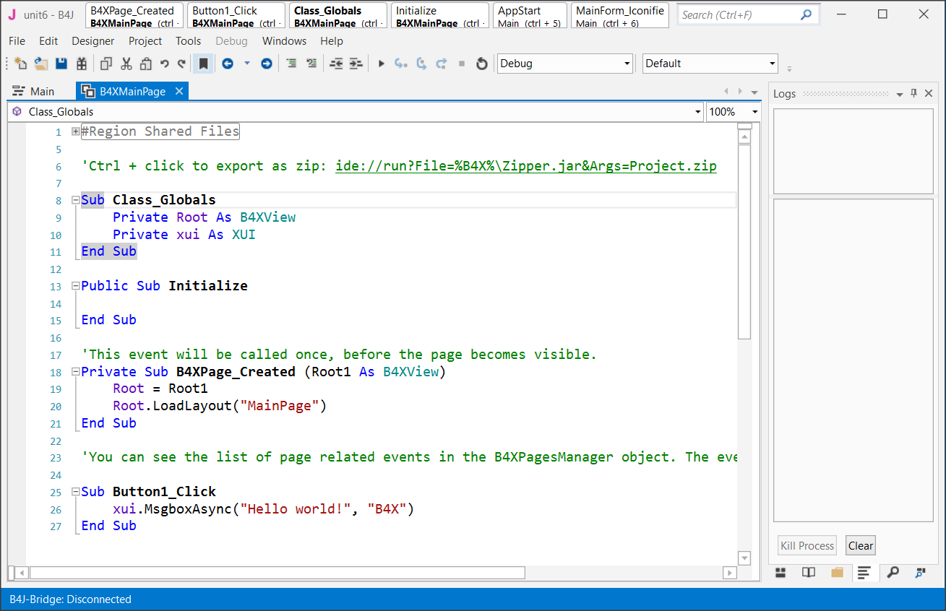

Do not worry about them now. We will discus later about them. Now all you need to know is that inside the B4XMainPage all the beautiful things happen for our code!

Now from the **Designer menu** select **Open Internal Designer.**

This is where the design process begins. Two windows will open, the first is the designer and the second is the preview of the screen you are designing.

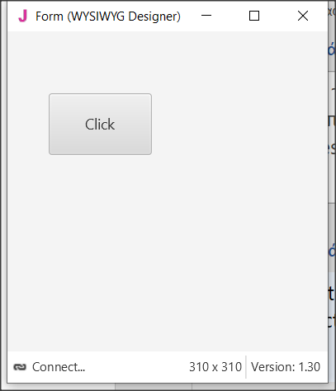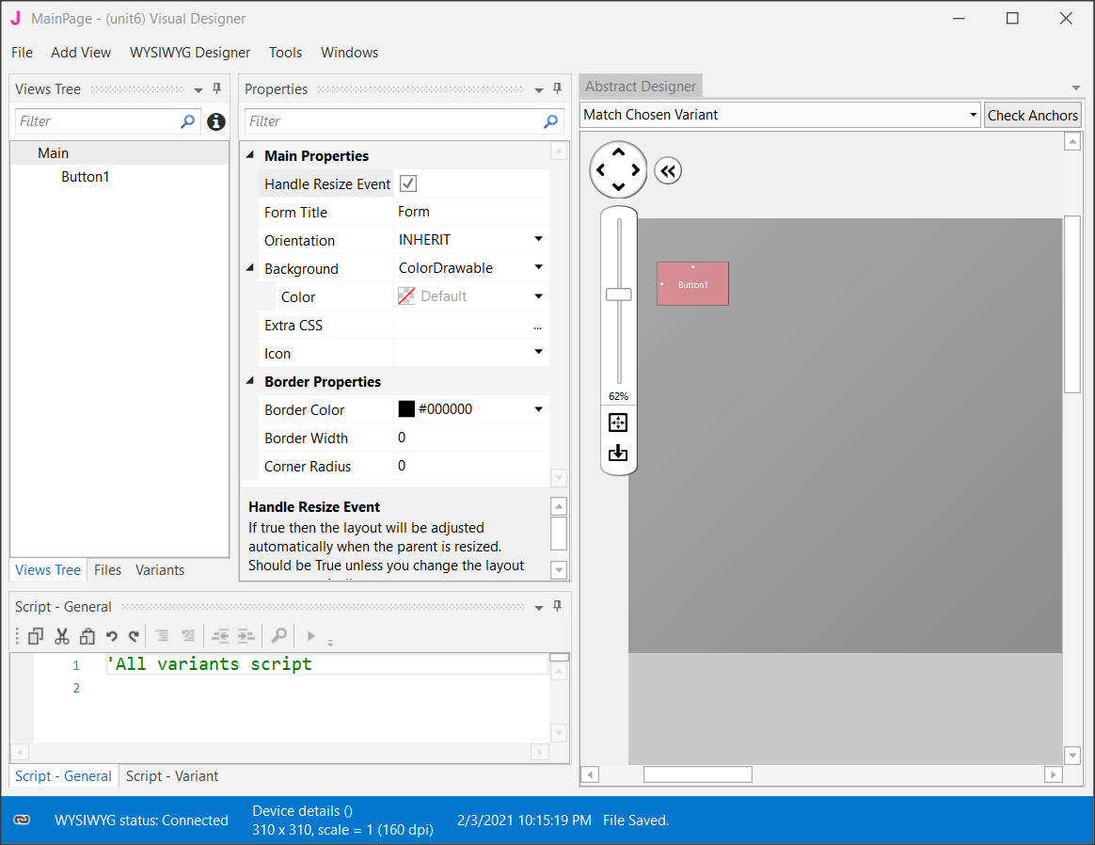

Figure Designer Screen

## Visual designer

The AddView menu includes all the objects needed to create our screen.

Select a label from the menu, and then move it to the preview screen where you decided before in the wireframe stage.

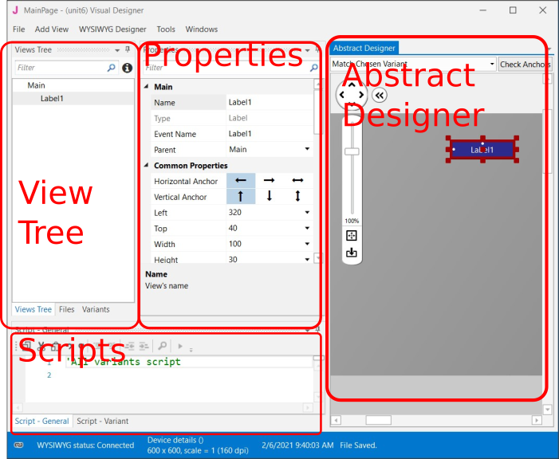

Figure Designer's parts

**Remember**

You can move all objects around the view by selecting them and holding the left mouse key.



### The Views Tree

Here you see all the objects in your design. Keep in mind that the objects above the list are placed behind the next ones.

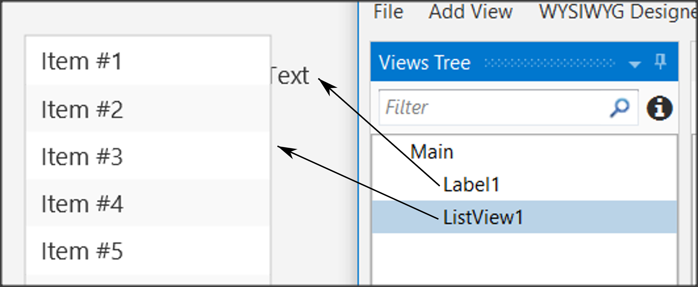

Figure Views Tree

### Properties

Each object has properties such as size, screen position, colors, font, etc. Each property can be changed either through the properties option or later through the program code.

One of the most important properties is the name of the object. This, like variables, should follow specific rules to indicate their type. For example in *Table 3* Naming objectssome cases of names.

|  |  |  |
| --- | --- | --- |
| **Type** | **Prefix** | **Example** |
| Label | lbl | lblName |
| Button | btn | btnSave |
| TextField | txt | txtAge |
| Spinner | spn | spnYears |
| Pane | pn | pnLine1 |
|  |  |  |

Table Naming objects

### Abstract Designer

The Abstract Designer allows to select position and resize Views. It is a very useful function for quickly placing objects in the correct position (however the most accurate placement is made by the Properties tab by setting the relevant values).

## Περιβάλλον εργασίας χρήστη/Εμπειρία χρήστη περίγραμμαExample 1

Imagine that you want to make a program that reads from the screen two Integers, calculates, and shows the sum.

### Decide on the size of the app screen.

This depends on the amount of information we must display as well as on the individual items such as menus, graphics etc.

To set the application’s size before beginning the Designer first go to **Main** Tab and change the first lines of code Width and Height:

#Region Project Attributes

#MainFormWidth: **600**

#MainFormHeight: **400**

#End Region

Save your project and open Designer.

### Set an appropriate variant.

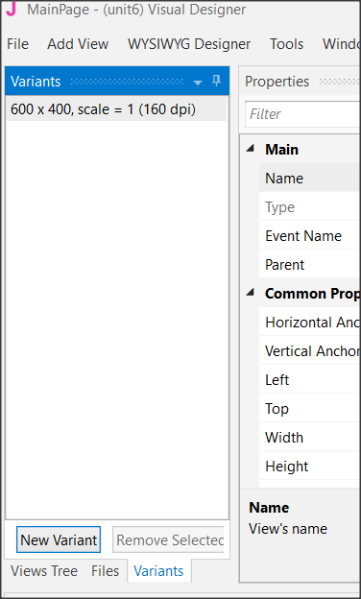

Figure Variants Screen

Usually, you should set the variant as the MainFormWidth and MainFormHeight. This will help you plan without the risk of going outside the screen limits.

Choose Variants and then New Variant and set the width and height.

You can have as many variants as you want for different screen size but for now, we stay to only one. Also, you can remove any variant by selecting it and choosing “Remove Variant”.

### Design a wireframe.

For small applications, this step is optional, but it is a good habit to have decided from the beginning where you want to display your details. You can use a simple sheet of paper or several programs to help create previews.

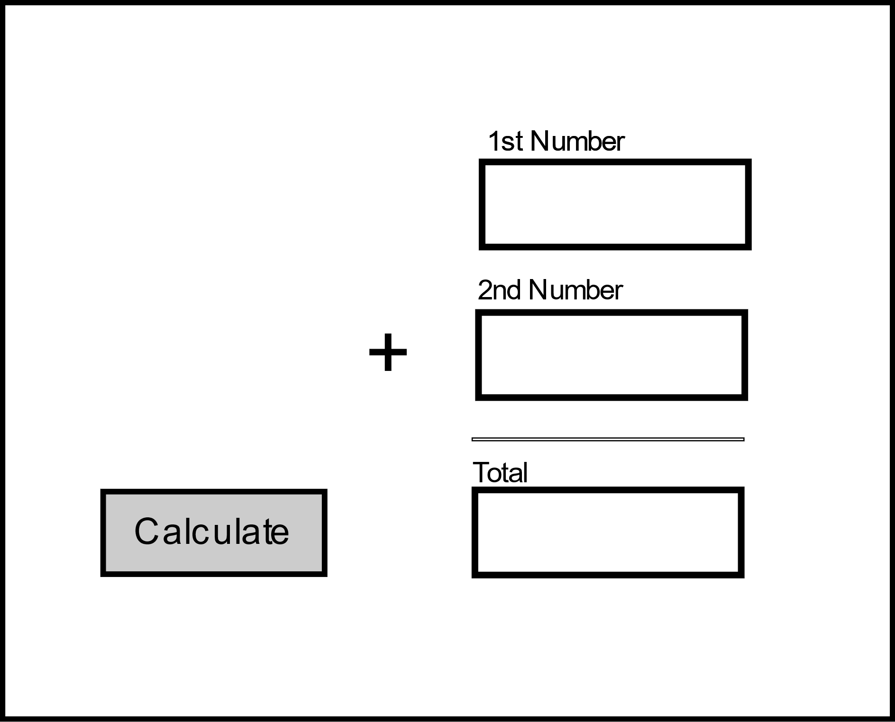

Label

Text Box

Button

Figure 8 Wireframe

### Create the views.

Now that you know what you need and where to place it, use the Designer tools to complete the process.

#### Inserting a label.

From View menu select label and you will see a label object in your View Tree and in the Abstract Designer. Move it in the place you decide in wireframing and choose an appropriate name from properties.

Now scroll down the Properties and set:

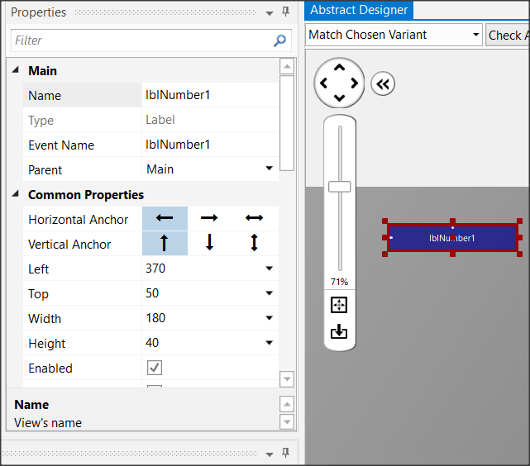

Figure Labels

* **Width**: 180
* **Height**: 30
* **Text**: First Number
* **Allignment**: CENTER_LEFT
* **Font**: SansSerif
* **Size**: 13

Experiment with the other settings and see it displayed in the preview pane.

Insert a second label or you can also dublicate the first one. Select it and press Ctrl-D. The second method gives a same label as the first one with the same properties except Name Property. Set “lblNumber2” as name and “Second Number” as Text and Create a third label with name “lblTotal” and Text: “Total”.

#### Inserting a Text Field.

Text Fields are used to import data into the program. There is no restriction on the type of data you can import. From View Menu choose TextField and set:

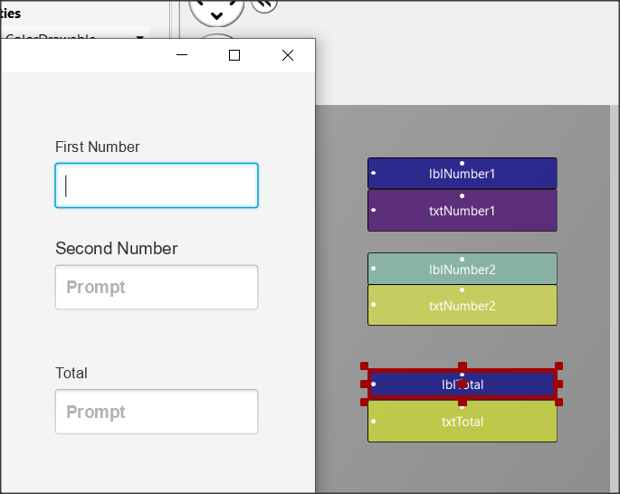

Figure Text Fields

* **Name**: txtNumber1
* **Width**: 180
* **Height**: 40
* **Font**: SansSerif
* **Bold**: checked

Place the textField underneath “First Number” label. Now put a same TextFIeld with name “txtNumber2” and put it underneath label “Second Number”. At the end create a third TextField with Name “txtTotal”. You will probably see something like the Figure 10 Text Fields

#### Inserting a button

Buttons in an app are used to enable functions. The program detects the click and then executes appropriate commands depending on the button pressed.

For each button you can set different features such as size, color, shape, etc. to stand out on your screen and be easily detected by users of your app.

From the Views menu select Button, and then set:

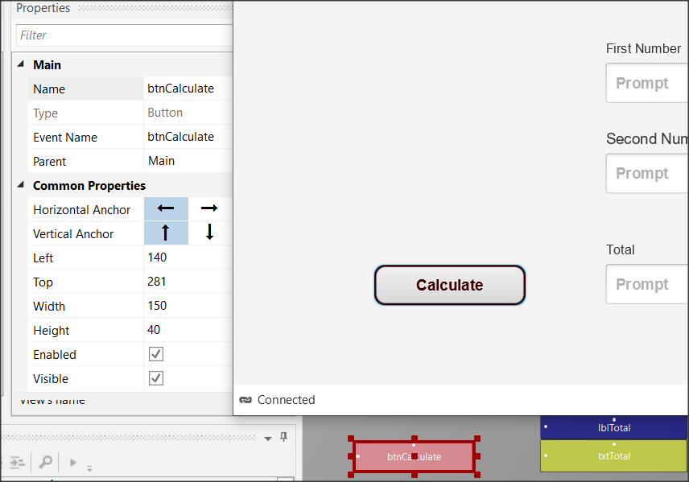

Figure Buttons

* **Name**: btnCalculate
* **Width**: 150
* **Height**: 40
* **Border Color:** #3C0000
* **Border Width**: 2
* **Corner Radius:** 20
* **Text:** Calculate
* **Text Color:** #FF3C0000
* **Font**: SansSerif
* **Size**: 15
* **Bold**: checked

**Remember**

**File -> Save** (or Ctrl – S) every time you make something valuable!



#### Inserting a Pane

You can use a Pane to visually group specific objects on the screen you're drawing. The pane displays a frame, and you can specify properties such as color, border, fill, etc. You can also use it at a very small height (1 or 2) to display a single line on your screen.

This example is used to draw a line before the total. From menu AddView insert Pane and set:

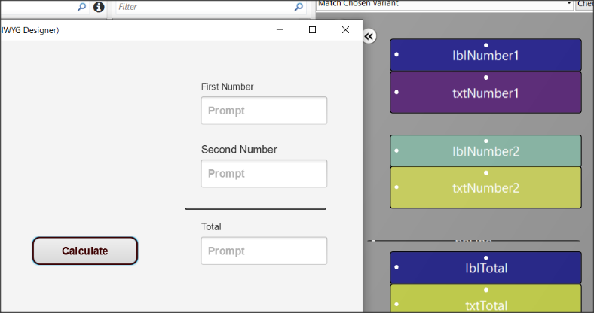

Figure Pane

* **Name**: pnLine
* **Width**: 180
* **Height**: 1
* **Border Color:** #000000
* **Border Width**: 2

Now from menu File save the form. The form has already a name (MainPage) so you don’t need to give an other name.

## Excercises

1. Use the designer to create the following wireframes.

**Teachers tip**

This is the fun part. You can also leave students free to experiment with views.



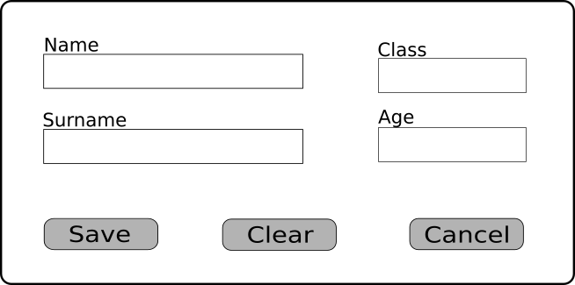

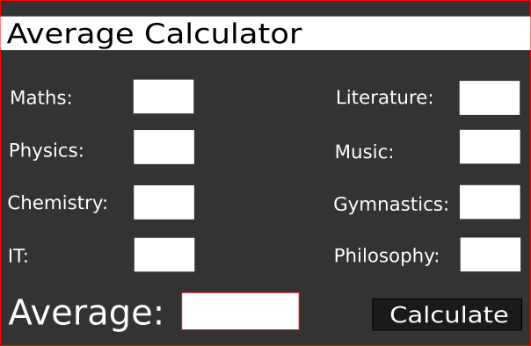

1. Think and design your own Dream Application. Give it a name, create a wireframe in your notebook and create the Design View.

# Lesson 6 – From Designer to Code

* Class_Globals
* Variables and Subs
* Passing Values to Code
* Events
* Attributes

What students should know

**2h**

Designing the app's appearance in Designer is the first step in the manufacturing stages. Often new developers turn to it to redesign, correct, or add individual information.

When the screen is ready the developer goes to the next stage of programming the functions. That is, everything that elements included in the design to gain functionality. In other words, text boxes can record data, buttons can activate functions, lists can display data, etc.

## Class_Globals

At the beginning of the code on tab B4XMainPage there is a set of variable declarations between Sub Class_Globals and End Sub.

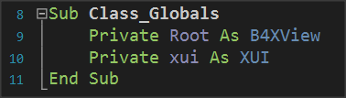As it has already been said in 3rd Lesson Sub is a set of code that performs a specific operation. The operation of the Class_Globals is to collect the declarations of variables that we want to be known throughout the code of the tab B4XMainPage, i.e. in each subprogram.

Picture Sub Class_Globals

In addition, if a variable statement starts with the public it will be available from other program "tabs".

## A deeper look at the use of variables.

In the following code you see three subprograms

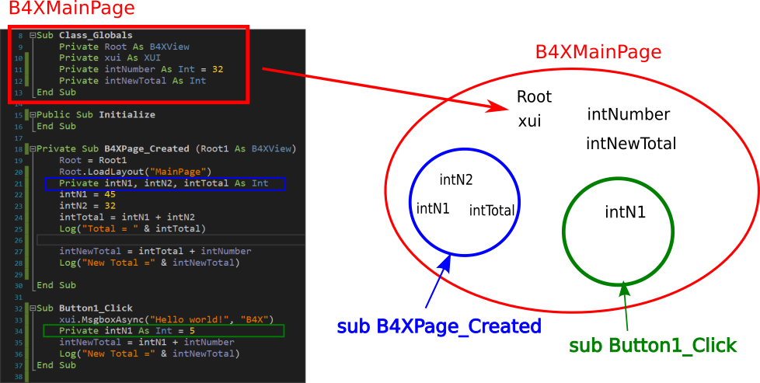

Picture Variables and Range

The intNumber, intNewTotal, Root, and xui variables declared within Class_Globals "live" within Module B4 XMainPage.

On the contrary, variables intN1, intN2, intTotal 'live' within the sub-program B4XPage_Created and for this reason No another subprogram may use them. At the same time, the variable **intN1** who lives in the **Button1_Click** **is not the same** with the one in **B4XPage_Created**, both has its own memory space, and both can have the same name.

**Teachers tip**

The use and range of variables is something that confuses new developers. Depending on your class, it is recommended to make examples of familiarity in their use.



## Passing Values to Code

The screen you have already prepared contains objects that you must declare as variables in Class _ Globals to use in the program.

In the example, in the previous lesson, some of the objects on the screen do not have to be included in the code.

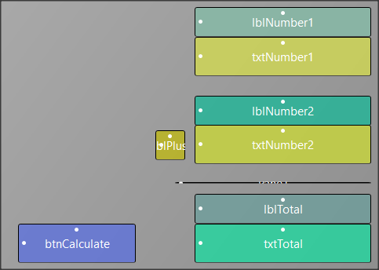

Picture Example 1 Designer View

So, all "labels" items in this application do not have to be managed by code as well as the pane element. While button and textFields must be added to schedule functions on them.

There are two ways to insert your objects into the code. The first is easily done through the designer with the following functions:

From the Tools menu select Generate Members

In Screen Generate Members just click on objects

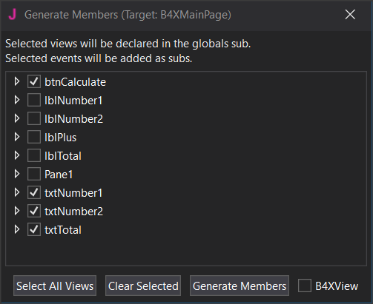

Picture 5 Generate Members

* btnCalculate
* txtNumber1
* txtNumber2
* txtTotal

and then click Generate Members.

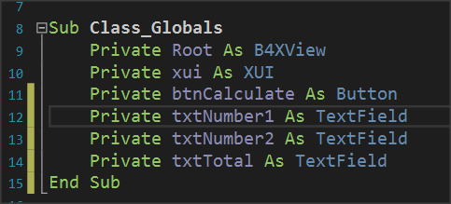

Picture 6 Class_Globals

Your code in the Class_Globals subprogram will be updated automatically with the variables.

**Remember**

Each object we import is of a certain type as well as the types of variables.



The second input solution is to write the variables yourself, paying attention so that the names of the objects on your screen are the same as those you write as a variable.

## Events

After you have declared the variables of the objects, the final stage is to enable the functions of the form.

This depends on how you've decided that each app works. In the example with the two numbers there is a button called Calculate and it is what will activate the addition as well as the appearance of the result on our screen.

The operation is triggered by a process called "**Event**. The programmer must detect the event of pressing the key Calculate and when this is done then do the relevant calculations and display the result.

**Remember**

There are hundreds of different events happening in one application; the developer determines how the program will react to each of them.



The detection of the event is easy and you just need to create a new subprogram that has the name of the event. This can be done at the same time as the declaration of the variables of our objects through the Designer.

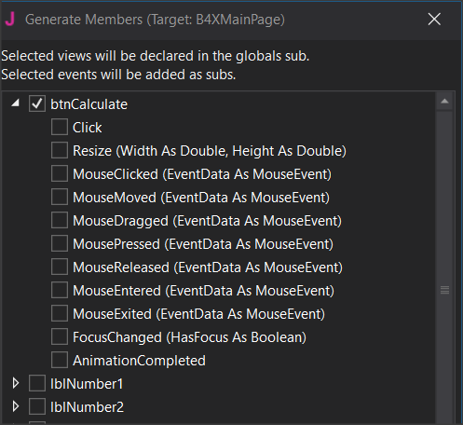

Picture 7 Setting Event

Open its list btnCalculate and several Events we’ll be available to choose. Just click on "Click” and "Generate Members”.

The subprogram for the **btnCalculate_**Click event has **already appeared.** Within it you will write the program code to complete.

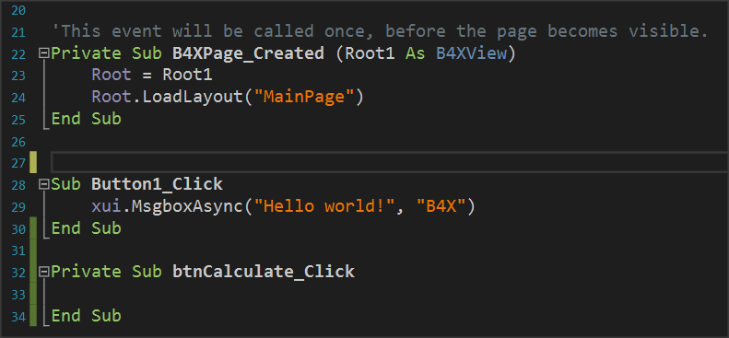

Picture 8 The Click Event

## Writing code in Event

Within an Event subprogram, all the functions associated with it are usually performed.

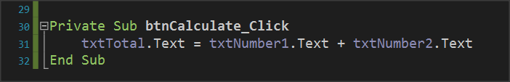

Picture 9 Calculating textFields

Essentially both are achieved with a single command. This is the command of Picture 9 Calculating textFields follows:

*The content of textField txtTotal* is equal to the contents of *txtNumer1* and *txtNumber2.*

### Properties

Each object you insert into your code has a number of different properties. For example properties can be the color, size, location content as they have been Described and in the previous lesson. These properties can provide information or change display issues. For example, the property txtNumber1.text provides information on the content of the object txtNumber1 or can set a value as content depending on how you use the. This information is type string.

**Remember**

You can do operations with string contents when they describe numbers.



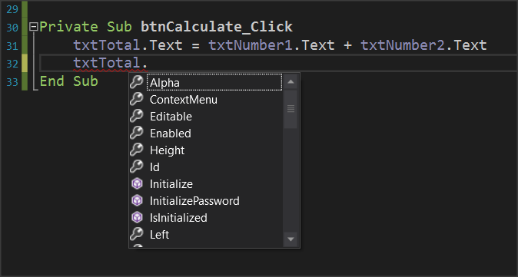

Picture 10 Object Properties

Let us now assume that we want to create a new function in the example where another key clears the form to write new numbers. The functions you will perform are as follows:

* Open Designer and add a new button named e.g. btnClear.
* Set it as a variable in Class_Global.
* Enter the event btnClear_Click.
* Set the text properties of txtNumber1, txtNumber2, txtTotal to "".

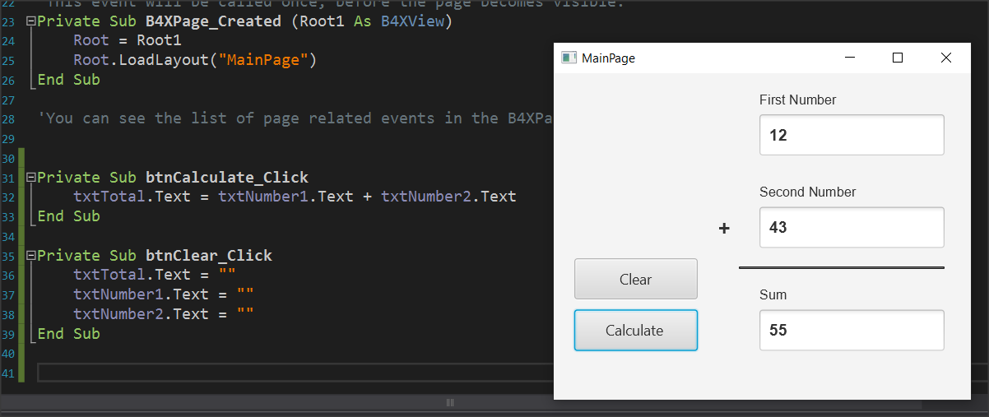

Picture 11 Clear Button and Code

When you press clear, the form will clear.

## Exercises

1. Extend the example to perform the four operations: Add, subtract, multiply, and divide at the click of an appropriate button. Add the appropriate objects to the designer and then complete the code.

2. In exercise 2 of the previous course continue and complete the application by activating its functions.

Take care that the numbers in lessons must be between 0-100. If not, you should show an error message.

# Lesson 7 – Conditional Statements

* Boolean Variables
* Relational Operators
* Logical Operators
* If Statement
* If-Else Statement
* If-Else-Else If Statement
* MAX Algorithms

What students should know

**4h**

## Logical Variables

So far, we have seen three types of variables integer, real, and string. As a type it is extremely simple because it can accept only two different values: True – False which in fact internally on the computer are translated into states 1 and 0 (leaked by current or not).

The statement of a logic (from now on we will call it Boolean) becomes like the other simple variables we have known:

**Private** intDistance = 100, intTotalTravel = 0 As **Int**

**Private** blnFlag  **As**  **Boolean** = False

**Private** blnDone As **Boolean**

## Comparative Operators

Comparative operators are used to make comparisons between values in the programming languages. They are the known mathematical symbols of inequalities only that on the computer are written in a slightly different way.

|  |  |  |
| --- | --- | --- |
| **Mathematical Symbol** | **B4X** | **Meaning** |
| = | = | Equality |
| ≤ | <= | Smaller or Equal |
| ≥ | >= | Greater or Equal |
| ≠ | <> | Different |
| < | < | Smaller |
| > | > | Larger |

Generally, to make a comparison you must compare variables or values of the same type. Eg. Integer values with integer values, real with real prices, etc. Also, in B4X you can compare numeric variables, such as integer variable and float, or Strings (strings) and numeric variables because internally the language converts strings into numbers.

**Remember**

The result of a comparison is always a logical value of True or False.



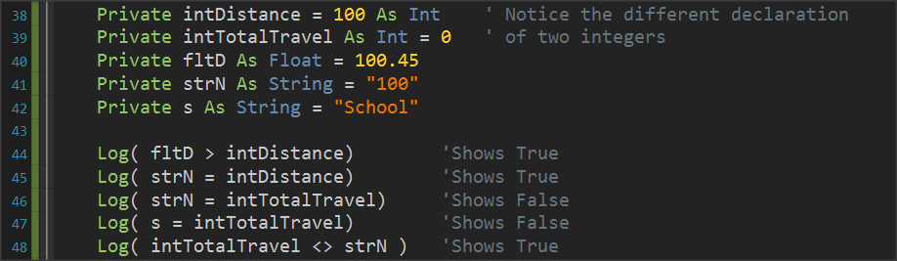

Picture 12 Variable Comparisons

## Logical Operators

Consider a sentence such as 'I am going to school now'.

Mathematician George Boole developed an algebra based on logical sentences.

In Mathematics and Mathematical Logic, Boolean Algebra is the algebra where the values of the variables are the true and false, usually represented by 1 and 0 respectively. Unlike elementary algebra where the values of variables are numbers and the main acts are addition and multiplication, in Boolean there are three main acts **And**, **OR** and Denial **No**.

**Remember**

**AND** (conjunction), denoted x AND y, satisfies x AND y = 1 if x = y = 1, and xANDy = 0 otherwise.

**OR** (disjunction), denoted x OR y, satisfies x OR y = 0 if x = y = 0, and x OR y = 1 otherwise.

**NOT** (negation), denoted NOT x, satisfies Not x = 0 if x = 1 and Not x = 1 if x = 0.



Example:

**1st Sentence**: Today it rains, **2nd Sentence**: *I am going to school*.

|  |  |  |  |  |
| --- | --- | --- | --- | --- |
| **Today it's raining.**  **(P1)** | ***I am going to school.***  **(P2)** | **P1 AND P2** | **P1 or P2** | **NO P1** |
| True | True | True | True | False |
| True | False | False | True | False |
| False | True | False | True | True |
| False | False | False | False | True |

From the table we observe that

* Two sentences that unite with the logical **AND** aretrue when it unites two truths only.
* Two sentences that are united by logical **OR** aretrue when even one sentence is true.
* The **logical** NO reverses the truth or lie of a sentence.

### Logical operators in programming

Logical operators are used in programming to create complex comparative expressions. This helps the developer optimize their code with fewer lines and simpler code.

In B4X logical variables are used as below.

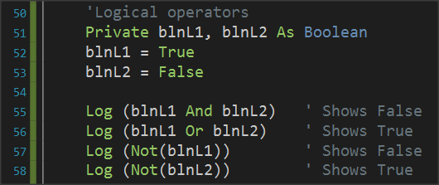

Picture 13 Use of Logical Acts

Notice that logical operations must link logical variables or logical expressions as we will see later.

### Examples of evaluation of logical sentences.

The following variables are given with their values:

**Private** intA = 10, intB = 20, = 30 **As** **int**

**Private** strName1 = “George”, strName2 = “Georgia”  **As**  **String**

**Private** blnA = True, blnB = False blnC = False **As** **Boolean**

Calculate the value of the following logical expressions.

1.

|  |  |  |
| --- | --- | --- |
| blnA | **AND** | blnB |
| True |  | False |
|  | **False** |  |
|  |  |  |

2.

|  |  |  |  |  |  |
| --- | --- | --- | --- | --- | --- |
| Inta | **>** | intC | **AND** | blnA |  |
| 10 |  | 30 |  | True |  |
|  | False |  |  |  |  |
|  |  |  | **False** |  |  |

3.

|  |  |  |  |  |  |  |
| --- | --- | --- | --- | --- | --- | --- |
| intA + intB | **>=** | intC | **AND** | (blnA | **OR** | blnB) |
| 10 + 20 |  | 30 |  | True |  | False |
|  | True |  |  |  | True |  |
|  |  |  | **True** |  |  |  |

4.

|  |  |  |  |  |  |  |
| --- | --- | --- | --- | --- | --- | --- |
| intA + intB | **>=** | intC | **OR** | (blnA | **AND** | blnB) |
| 10 + 20 |  | 30 |  | True |  | False |
|  | True |  |  |  | False |  |
|  |  |  | **True** |  |  |  |

5.

|  |  |  |  |  |  |  |
| --- | --- | --- | --- | --- | --- | --- |
| strName1 | **=** | “George” | **OR** | strName2 | **=** | “John” |
| George |  | George |  | Georgia |  | John |
|  | True |  |  |  | False |  |
|  |  |  | **True** |  |  |  |

## If command

Often as in life we ask questions so in programming there is a need for the developer to ask questions to check values or change the continuity of the program in different directions.

The **if command** is used to make the corresponding questions:

Its basic form is as follows:

**If** ( condition ) **Then**

Commands

**End If**

Where condition enter a comparative or logical expression studied above.

The meaning is: If condition is **TRUE** execute the commands between Then and End If

Examples:

**Private** intA = 10, intB = 20 **As Int**

**Private** fltA **As Float**

**If** intA > 0 **Then**

**Log**(intA & " is positive Number")

**End If**

**If** intA > 10 **Or** intB > 10  **Then**

**Log**("One or both numbers are greater than 10")

**End If**

**If** intA **Mod** 2 = 0 **Then**

**Log**(intA & " is Even number")

**End If**

## If – Else

The Else command adds the ability to **if** to execute code if its condition is not true.

Its basic form is as follows:

**If** ( condition ) **Then**

Commands

**Else**

Commands

**End If**

The meaning is: If condition is **TRUE** execute the commands between Then and Else otherwise Execute the commands between Else and End If.

Examples:

**Private** intA = 10, intB = 20 **As**  **Int**

**Private** fltA **As Float**

**If** intA > 0 **Then**

**Log**(intA & " is possitive Number")

**Else**

**Log**(intA & " is not possitive Number")

**End If**

**If** intA > 10 **Or** intB > 10 **Then**

**Log**("One or both numbers are greater than 10")

**Else**

**Log**("None of the two numbers are greater than 10")

**End If**

**If** intA **Mod** 2 = 0 **Then**

**Log**(intA & " is Even number")

**Else**

**Log**(intA & " is Odd number")

**End If**

## If – else - else if

Multiple **if** further extends the functionality of an **if** command by adding more than 1 control to the structure.

How to write:

**If** ( condition1 ) **Then**

Commands

**Else If** (condition2 )  **Then**

Commands

**Else If (** condition3 ) **Then**

Commands

**Else If (** condition4 ) **Then**

Commands

**...**

**Else**

Commands

**End If**

The function of the multiple if is summarized as follows:

1. The first condition runs, and if it is true, then the code it contains runs and if it is completed.
2. If the first **if** is false then the second is executed and if it is true it executes the code it contains and if it is completed.
3. Other checks are always performed when the previous ones are false.
4. If none of the checks are true then the **else** command is run which is optional.

Example 3

A fast-food chain has these meals:

|  |  |
| --- | --- |
| Meal | Price |
| Burger | 5$ |
| Pizza | 3$ |
| Hot Dog | 1,5$ |

Create a program that:

Reads the meal the customer wants. Prints the cost of the meal. Input example: "Hot Dog", Output: "Hot Dog 1,50$"

Solution

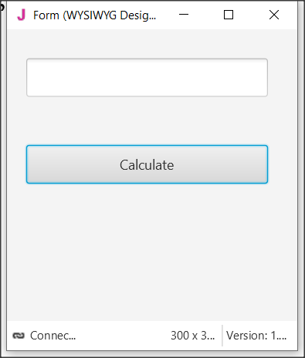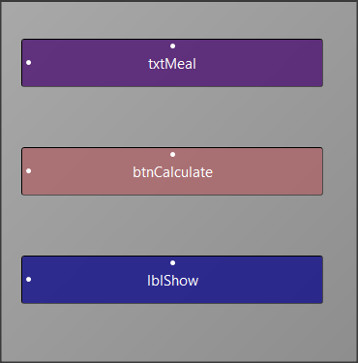

Picture The app screen

**Step 1**

Start a new project and give dimensions 300 x 300.

**Step 2**

In the designer design the app screen

**Step 3**

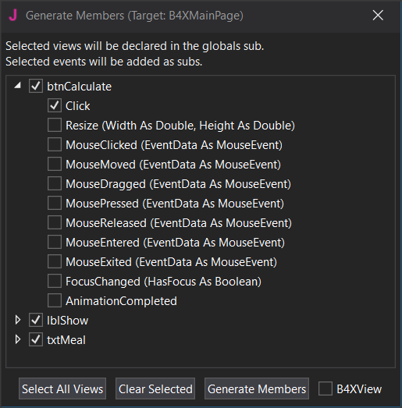Enter txtMetal , btnCalculate, lblShow , and btnCalculate_Click.

**Step 4**

The code you need to write is for btnCalculate_Click

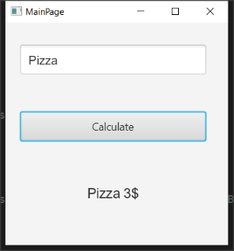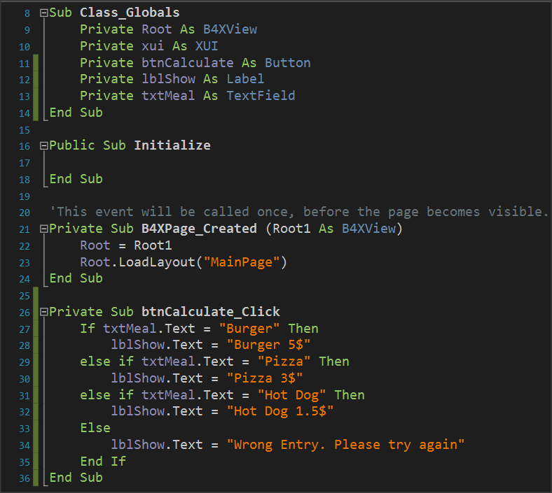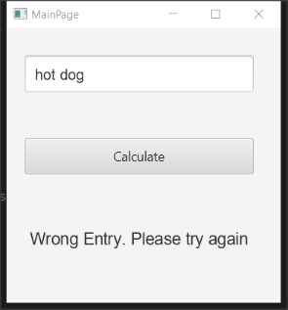

Note that the code considers capitals to be different from small letters. So he doesn't recognize the hot dog as a meal that should be written as a Hot Dog.

## Algorithms with if

Find Maximum Number

Read 3 integers and find the largest in three different ways

Method 3 – Max Algorithm

**Max = inta**

**If** intB > Max  **then**

MAX = intB

**End If**

**If** intC > Max  **then**

MAX = intC

**End If**

**Log(**Max**)**

Method 2 – Nested If

**If** Inta > intB **then**

**If** Inta > intC **then**

**Log**(Inta)

**End If**

**End If**

**If** IntB > IntA  **then**

**If** IntB > intC  **then**

**Log**(IntB)

**End If**

**End**

**If** IntC > IntA  **then**

**If** IntC > IntA  **then**

**Log**(IntC)

**End If**

**End If**

Method 1 – Simple If Statement

**If** Inta > intB  **AND** Inta > intC  **then**

**Log**(Inta)

**End If**

**If** intB > Inta  **AND** intB > intC  **then**

**Log**(intB)

**End If**

**If** intC > Inta  **AND** IntC > intB  **then**

**Log**(intC)

**End If**

## Exercises

1. Make the following suggestions in logical expressions.
   1. A belongs to space [-5, 6).
   2. a is less than 3 or more than 15.
   3. a is equal to b and c.
   4. a does not have a value of 3.
   5. A is less than 2 or b is greater than 78.
   6. a and b true and c false.
   7. the a true and one of the b, c true.

1. What is the logical result (true or false) of performing the following operations if the following variables have the values below?

A = 10, B = 2, C = -4, D = 9 and E = 1

* 1. (A>B) or (D=10)
  2. (D >= B) and (E <> C)
  3. no (E<=C) or (D<=C)
  4. no ((B<=C) and (D<2))
  5. no (no (B<=E) or not (C<=B))
  6. ((E<=A) and (E>=C)) and not (C>=A)
  7. no (no (A >= 2) and (C <>9))

1. A fast-food chain has these meals:

| **Meal** | **Price** |
| --- | --- |
| Burger | 5$ |
| Pizza | 3$ |
| Hot Dog | 1,5$ |

Create a program that:

Reads the meal the customer wants and second how many items of this meal needs.

Prints the cost of the meal.

Input example: "Hot Dog", 2

Output: " 2 x Hot Dog 3$"

1. You have consumed X amount of Mbps on Wikipedia and Y amount of Mbps on memes. The cost of visiting Wikipedia is 0,10$ per Mb and the cost for watching memes is 0,05$ per Mb. If total consumption is more than 100$ print "Too much consumption". If watching meme consumption is greater than reading Wikipedia consumption print "WOW MANY MEMES", "SUCH LOL"(in new line). Create a program that:
   1. Reads X (Wikipedia Mb consumption) and Y(watching meme Mb consumption)
   2. Calculates the total consumption.
   3. If total consumption greater than 100$ print proper message If watching meme consumption is greater than reading Wikipedia articles print proper messages
2. An internet cafe has 2 ways of charging. If the user is a member pays 2$/hour, Else the user pays 5$. Find if someone is a member or not and calculate the price based on how many hours the user spend. If the user is a member the tax is 10% else the tax is 20%. Create a program that:
   1. Reads how many hours the user spend
   2. Check if is a member.
   3. Add the proper tax fee.
   4. Print the total amount the user must pay Output: "The user is a member stayed 2 hours for 2$/hour plus the 10% the total amount is 4.4$"
3. You want to buy something from Amazon. The seller charges different prices for shipping cost based on location. For US it's 5$ for Europe it's 7$ for Canada it's 3$ for other places it's 9$. Create a program that:
   1. Reads the cost of the product.
   2. Reads your location.
   3. Print the amount of money you must pay.
   4. Output: "You have to pay 23$, 20$ for the product and 3$ for shipping cost".
4. A company sells a product for 0.70 € a piece if up to 200 pieces are ordered and for 0.50 € a piece if more than 200 pieces are ordered. Read the number of pieces ordered and calculate their value.
5. A cell phone company has the following billing policy.

|  | **Fixed cost 25$** |
| --- | --- |
| Call duration(in seconds) | Charge($/per second) |
| 1-500 | 0,01 |
| 501-800 | 0,008 |
| 801+ | 0,005 |

Create a program that:

* 1. Reads how many seconds was the calls duration.
  2. Calculates the monthly bill for the subscriber.
  3. Prints the total amount.
  4. Output: "total amount: 48$"
  5. Notice that that the charge for the first 500 seconds it's 0,01$ then for the next 501 to 800 seconds it's 0,008 and then it's 0,005$

1. In the qualifying races in the long jump at the Olympic Games, an athlete makes 3 initial attempts and if he has a performance of more than 7.50 meters, then he is entitled to continue and make another 3 more attempts. Read the first 3 attempts of an athlete and print a message whether he is entitled to continue or not and if he is entitled to find and print the best effort of the athlete.

**You can use method Visible = True or False to hide or show labels, textFields and Buttons.**

1. In a municipality there are parking spaces for a short period of time. Parking charges are staggered, as shown in the table below:

|  |  |
| --- | --- |
| **Parking time** | **Charge per hour** |
| Up to 1 hour 3.50 € | |
| The next 2 hours | 8.00 € |
| The next 2 hours | 12.00€ |
| Over 5 hours | 15.00 € |

Make a program that reads the duration someone left his car in parking and calculates the total cost.

# Lesson 8 – Subroutines

* What is a subroutine.
* Declaring a Sub
* Passing Values
* Returning Values from a sub

What students should know

**3h**

In computer programming, a subroutine is a sequence of program instructions that performs a specific task, packaged as a unit. This unit can then be used in programs wherever that task should be performed.

Subroutines may be defined within programs, or separately in libraries that can be used by many programs. In different programming languages, a subroutine may be called a routine, subprogram, function, method, or procedure. In general, to create a subprogram, the developer should keep the following in mind:

The subprogram should only do one task.

Be relatively small and ideally no larger than a screen so that it can be read easily.

Have such a name that refers to its function.

## Create a subprogram in B4J

You have Button1_Click already encountered subprogram in B4J that the language has prepared. Notice that events like Button1_Click are also a routine to serve the event.

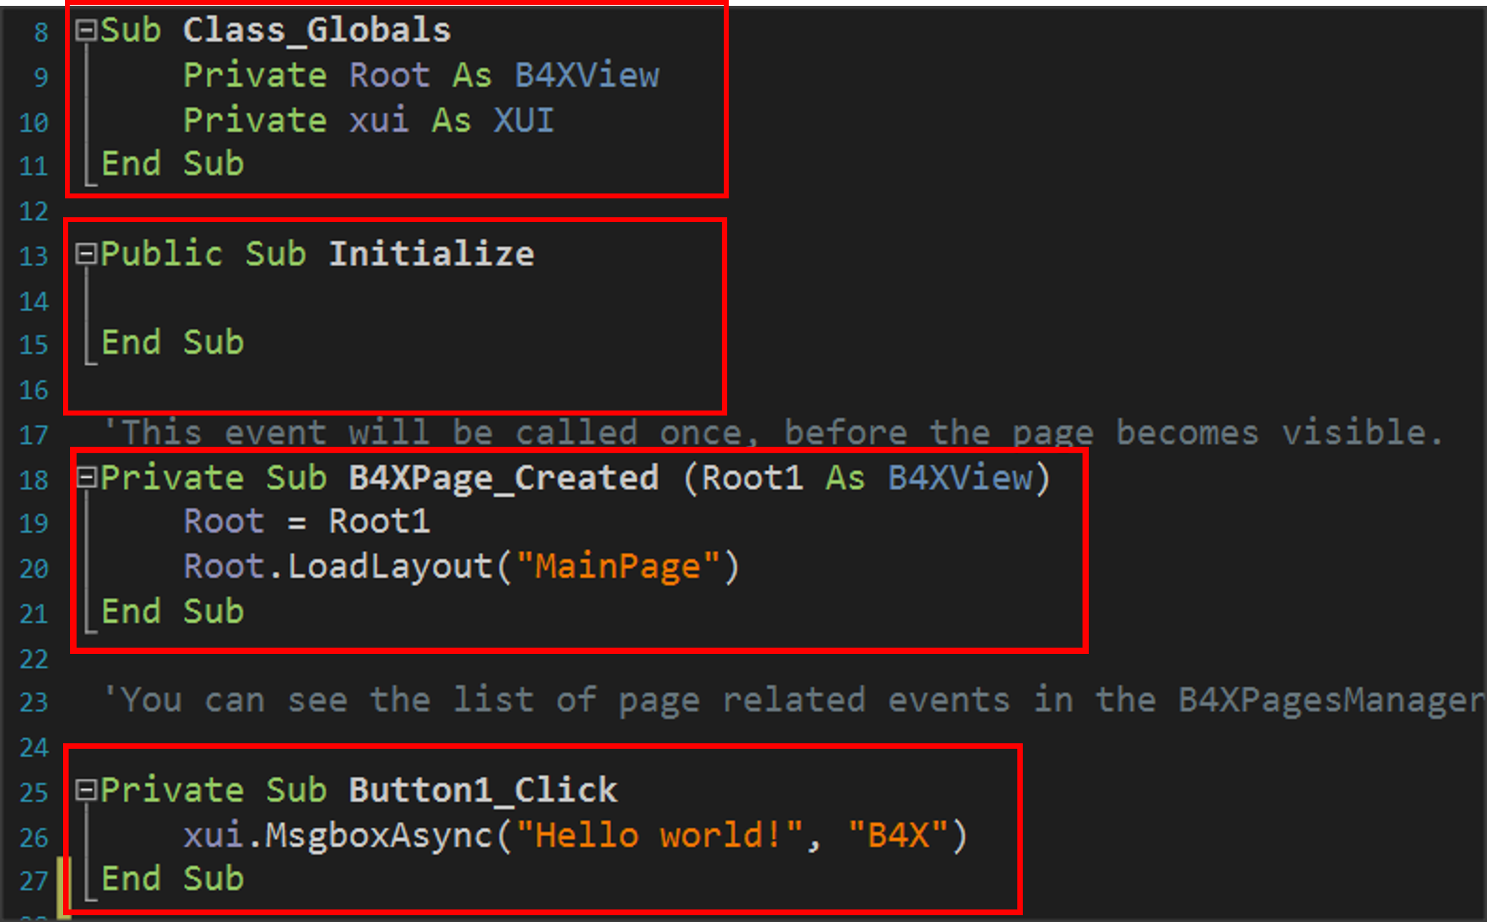

Picture Subprograms

### Example 1

Suppose a function needs to be performed, such as adding two numbers given by the user. As a program it is very simple and generally does not need a subprogram for such a function. Here we will use a subprogram to understand how it is used and operated.

The two integers intA and intB have been declared in the program, values have been assigned, and then the showSum1 routine is called.

This is done by writing the name of the routine (which the developer decides) and then in parentheses the variables whose values it must know to function.

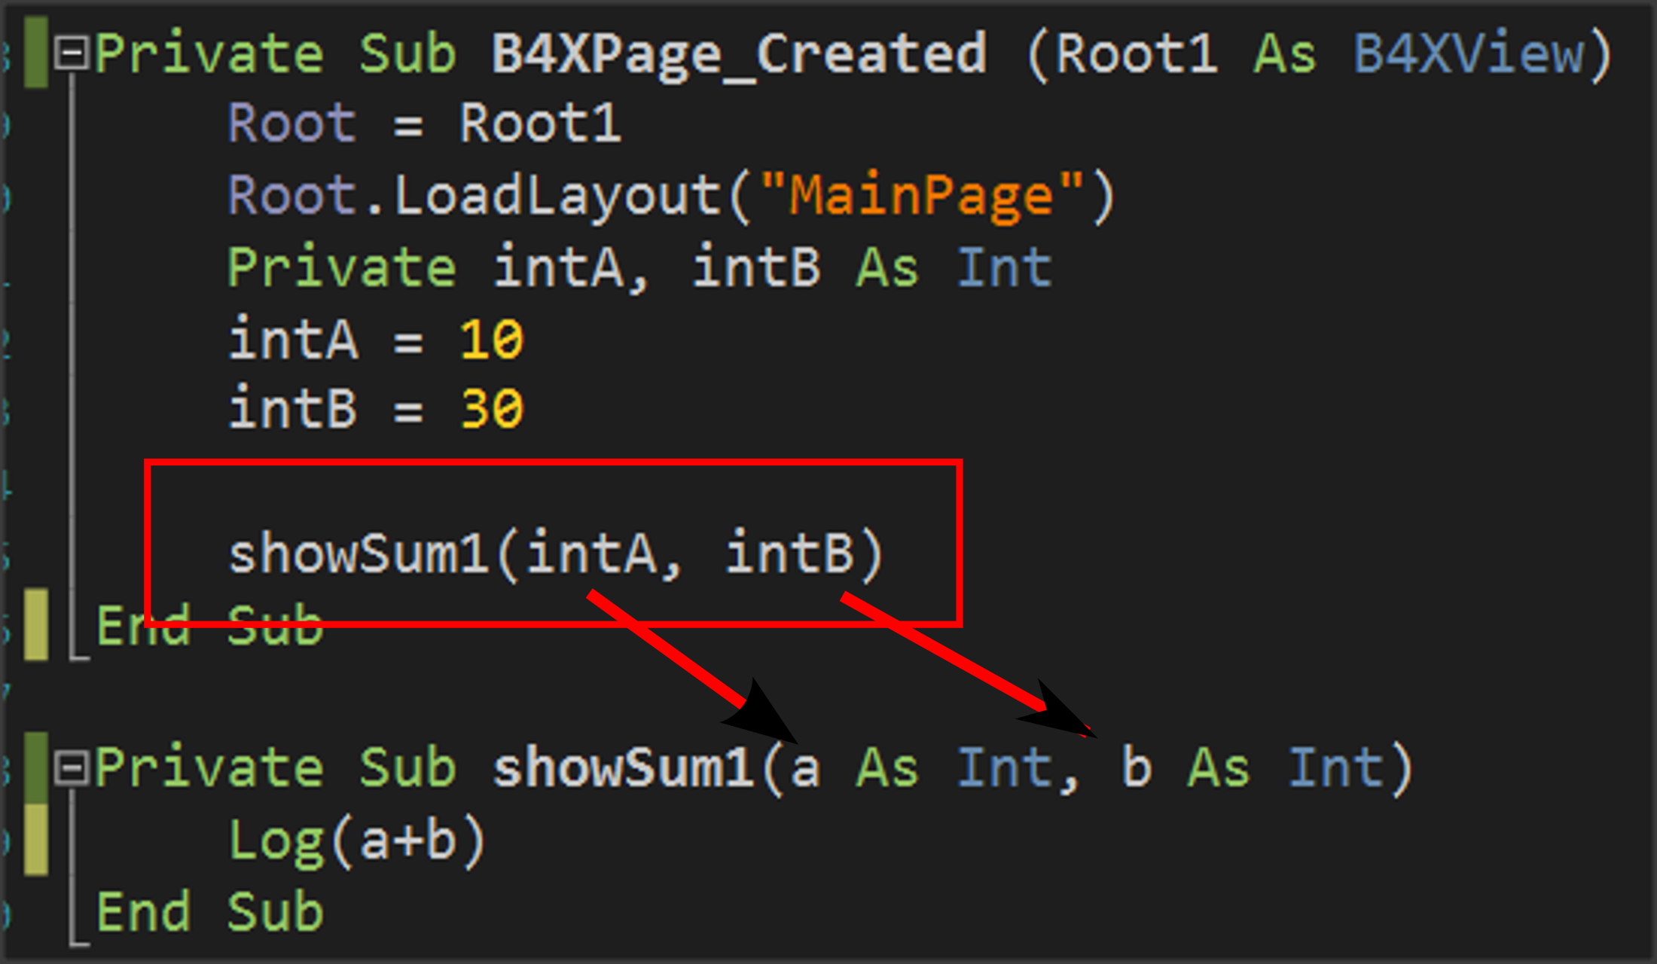

Picture Calling a subprogram

The subprogram is written before or after the current subprogram:

It always starts with the **Private** statement which means that it is a subprogram that will be known only in the code (B4XmainPage) or **Public** for the subprogram to be known in other parts of our application.

The Sub statement which means subroutine and

In parentheses, the names of the variables that will receive the data from the call point are indicated.

Notice in the image that this data enters in the order written when calling the routine, i.e. the value of the intA will enter in variable a and the value of the variable intB will enter in variable b.

**Remember**

Variables exchanged between subprograms during their call are called **parameters**.



The subprogram now works with data contained within parameters a and b not the intA and IntB.

## The memory of the subprogram in B4X

Each subprogram has its own memory space to store their variables. An exception to this rule is the **Class_Globals** subprogram, whose data is known to all B4XMainPage routines and can be reported to them by name.

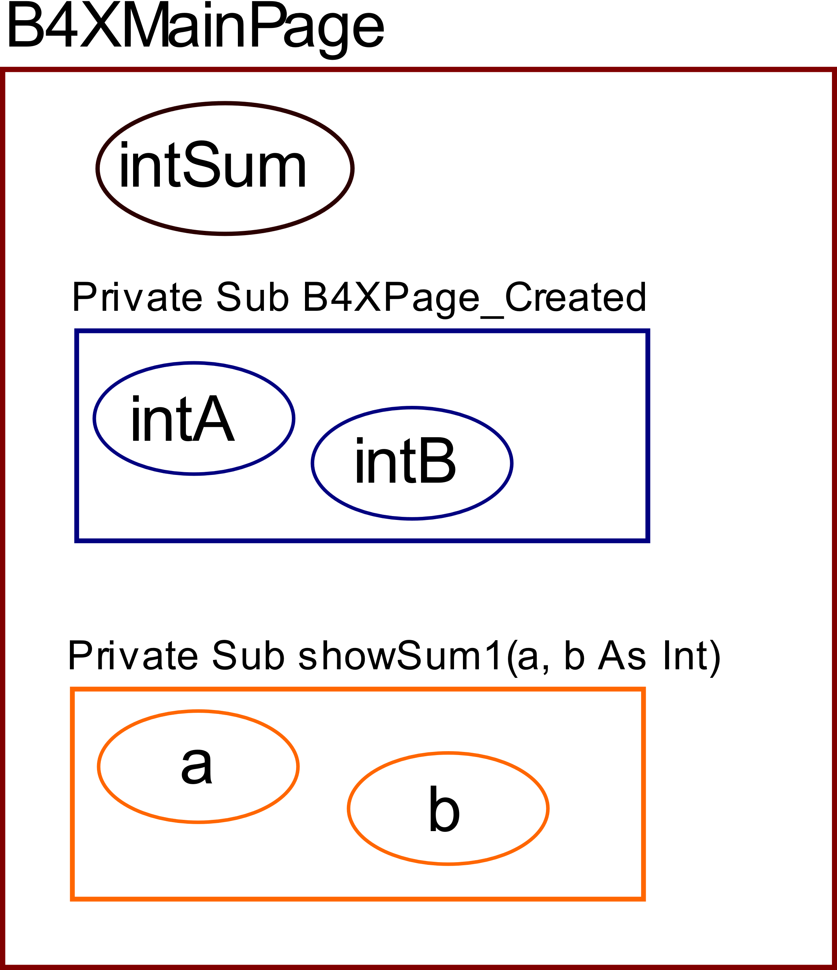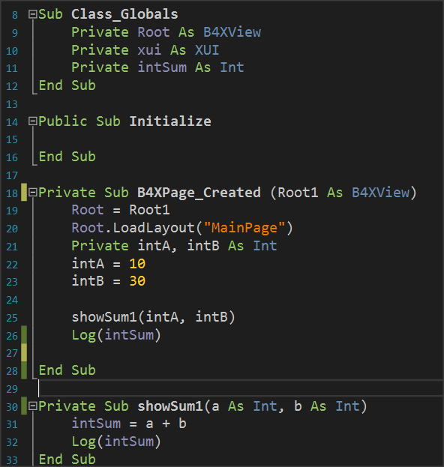

Picture The Memory

From the image code you can notice that the variable intSum is known in both subprograms and is used simply by writing its name. In B4X these variables are displayed in a different color so that the developer can Distinguish easily. On the contrary, variables declared within the remaining variables live only within them and another subprogramm cannot use them by name.

**Remember**

Variables declared within Class_Globals are known in all subprograms and are called **Global.**

The variables declared within the subprograms are called **local** and are not known in the rest program.



## Return a value from a subprogram.

A subprogram can return a value to the code that calls it. This is done through the subprogram name itself as follows:

The program must be declared as a variable type.

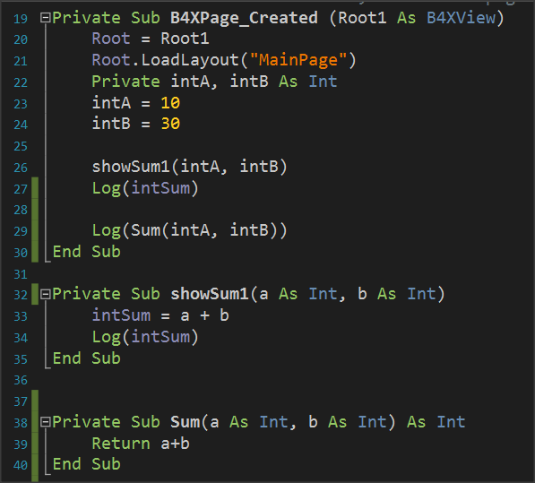

In addition, the return command must be used within the subprogram to return the calculated value.

Finally, the code that called the subprogram accepts back the value calculated and can use it like any variable.

Picture 18 Returning Values back to program.

**Remember**

Often routines that return values to the code that calls them **are** also called Functions.



## Example 2

Write a subprogram that accepts 3 integer variables and returns the largest value.

Three integer variables (Inta, intB, intC) are declared within subprogram B4XPage_Created.

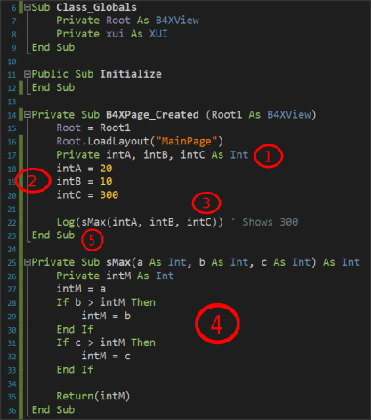

Picture Example 2

Values are assigned to the three variables.

The sMax subprogram is called with parameters the three variables.

The subprogram applies the MAX algorithm for the three variables a, b, c and returns the intM value calculated.

Finally, the highest value appears on the Log screen.

**Remember**

We love subprograms because:

* It is boring to always write the same code.
* It is faster than anyone can type.
* It is helping not to repeat the same mistakes. You have done it once!
* Cool programmers write subprograms.



## Exercises

**Teachers tip**

Encourage students to solve all exercises and discus the solution in class. Dedicate at least 1 hour to explain them.



1. Write a program that calculates the area of a circle. The user must enter the radius of a circle in an appropriate textField, and then using a subprogram to calculate and return the area.
2. Write a program that calculates the solution of the secondary equation ax2 + bx + c = 0.
   1. The user must enter the equation coefficients in appropriate TextFields.
   2. The result appears in one, or two textField depending on the value of the Discriminant.
   3. The Discriminant must be calculated with a subprogram that returns its value.
   4. It will not be permissible to calculate the Discriminant factor unless all the fields of factors a, b, c are filled in.

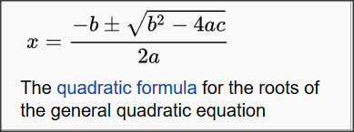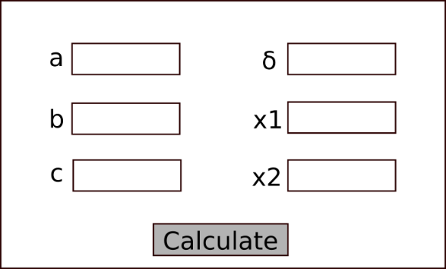Note to display the error message use **xui.MsgboxAsync("Message","Title")**

Picture Source: Wikipedia.org

Picture Wireframe

1. Make a program that uses the turtle and draws squares with a side given by the user. Create a subprogram that accepts the side and then draws the square starting from where the turtle is already located and moving clockwise.
2. One theatre has three categories of tickets, Arena, Gallery, Proscenium. Each ticket costs 20, 30, 40€. Make a program that:
   1. Reads the code 1, 2, 3 representing respectively the categories.
   2. Reads the number of seats he wants.
   3. Calculate the value of tickets with a subprogram that returns the amount, and which will be displayed in an appropriate textField

# Lesson 9 – Classes

* What is a Class?
* What is an Object?
* What are Attributes and Methods?
* Create and use simple class with B4J.

What students should know

**3h**

Often in programming there is the need to describe similar items in a single way. For example, pupils of a school. Each student is known to have a full name, home address, class to attend, some grades, etc. To monitor and manage this information, a programmer must organize them with systematic way.

**Teachers tip**

Classes are a tricky subject of programming. Avoid many details and you do not need to go into issues such as inheritance, encapsulation, etc.



## Classes

In the previous example with students, we could say that each student has the following information.

|  |  |
| --- | --- |
| **Student** | |
| 1 | Registry Number |
| 2 | Name |
| 3 | Surname |
| 4 | Address |
| 5 | Phone |
| 6 | Email |

At the same time, we need functions such as:

* New Student Registration
* Change Student Information
* Student Transfer
* Show Student Information
* Delete Student

Thus, for three students we could have the following elements:

|  |  |  |  |  |  |  |  |
| --- | --- | --- | --- | --- | --- | --- | --- |
| **Student 1** | |  | **Student 2** | |  | **Student 3** | |
| 1 | 125310 |  | 1 | 125311 |  | 1 | 125312 |
| 2 | Augusta |  | 2 | Maria |  | 2 | Muḥammad |
| 3 | Ada Byron |  | 3 | Curie |  | 3 | al-Khwarizmi |
| 4 | London |  | 4 | Warszawa |  | 4 | Khwarazm |
| 5 | 37535795 |  | 5 | 678433 |  | 5 | 646456456 |
| 6 | ada@lon.uk |  | 6 | maria@wars.pol |  | 6 | algor@khwa.pe |

From the above we conclude that essentially for students we have similar data and similar actions that we can apply to them. Grouping all student data and functions into an independent and single code is called class. Every student Called **Object** or **Instance** of the class. Also, the variables that characterize the student surname, Registry number etc. Called **Properties** and the functions Described **Methods**.

**Remember**

We call **class** the grouping of data and functions into a single and independent code.

**Object** or **Instance** of the class are all independent elements that result from the use of the class.

Variables for an object are called **properties.**

The functions applied to an object are called **methods.**



Some of the advantages of using classes are flexibility in the use of code, speed and ease in developing programs and reusing code in other programs.

## Example of class in B4J

A library has a set of books which it lends to readers who subscribed in the library. Each book has features such as title, author, publisher, year of publication. Also, the Insert Book, Show Book Items, Change Book Items functions apply to each book.

Create an application in B4J that implements the Book class with the properties and methods mentioned above.

### Implementation methodology

1. Create a new application B4XPages and give the name “library”.
2. 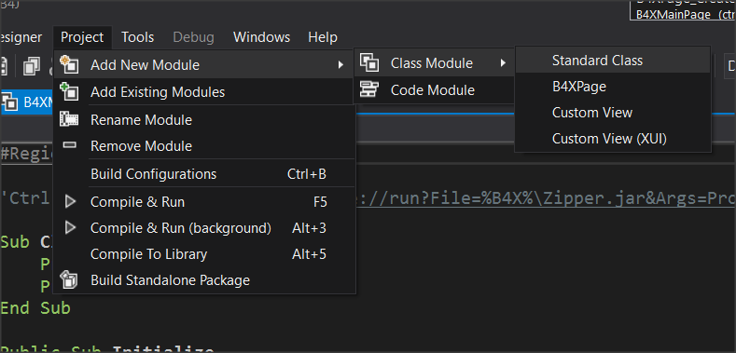From menu Project – Add New Module – Class Module menu select Standard Class.
3. In the dialog box, name clsBook (i.e. class Book)
4. A new code tab named clsBook will be created.

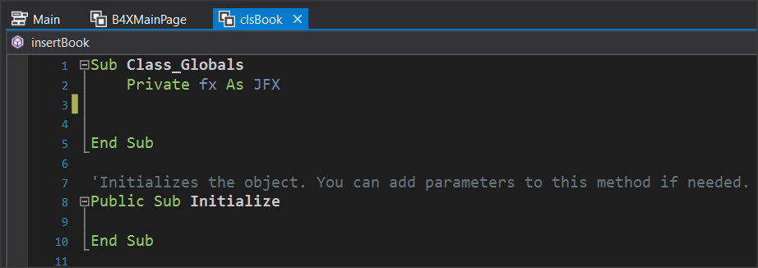

1. Within the Class_Globals routine, add all the variables that will be the properties of the class.
   1. Book Title
   2. Author Name
   3. Publisher
   4. 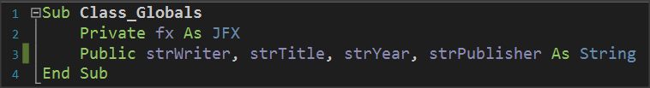Release Date
2. Finally, you must implement the subprograms that will implement the methods:
   1. Insert a book,
   2. Show Book Items,
   3. Change Book Items

**Teachers tip**

Be careful to explain that all the variables and methods you create are public so that objects can use them.



### Insert a book.

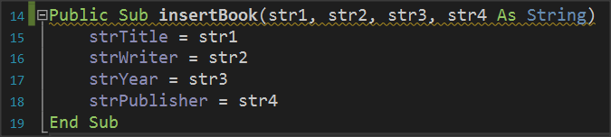This is a subprogram that accepts 4 string data as parameters and then assigns it in the order that it is inserted into the subprogram into the variables strTitle, strWiter, strYear, strPublisher.

### Show Book Items.

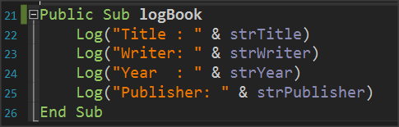The subprogram displays with log command the properties of the Books class or in other words the variables that describe the class.

### Change book items.

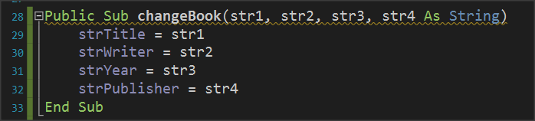The method of changing items accepts as parameters new elements for the class and changes the property values of the corresponding properties.

### The Initialize subprogram.

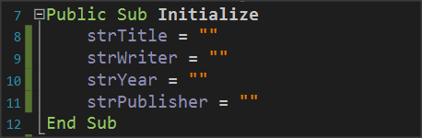The Initialize routine is used to give initial values to variables or do any other functions required when creating an object from a class.

### Use Class

Back on tab B4XMainPage it's time to use the clsBook class.

1. First create clsBook objects.

where book1, book2 are two clsBook objects with all the properties and methods discussed previously.

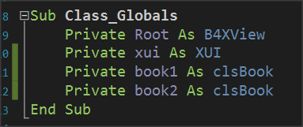

### Use of methods

The first method to be used in objects is the initialize method.

**Remember**

Initialize is not optional method. It’s the first method you must use before do anything with an object



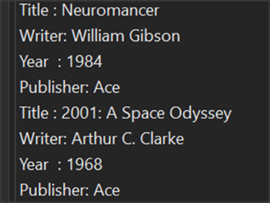The InsertBook method then enters values for the two books in the object properties.

End the logbook method displays the contents of the properties of each book.

**Remember**

Each property can be called by writing the object name, then a period and the method name. Some methods need parameters to work while others don't.



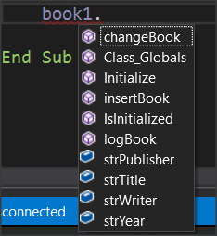Each time you write an object name and pressing the period B4X displays a window with all available properties and methods of the class. The IsInitialized method checks whether the object is initialized and exists in all classes that you create.

## Exercises

1. In the first example of the course, implement in B4J the Student class with properties:

* Registry Number
* Name
* Surname
* Class
* Phone
* Email

and methods

* New Student
* Show Student
* Change Class
* Change Phone

1. If only one teacher teaches a specific course in a school implement the Course class with properties
   1. Lesson
   2. Class
   3. Hours
   4. Professor

and methods

1. New Lesson
2. Change Hours
3. Change Professor
4. Show Lesson
5. A store has computers for sale. For each computer are recorded:
   1. The type (desktop, laptop),
   2. the model,
   3. its price,
   4. Its cpu (I3, i5, i7, i9)

Create a class that implements a computer with the above properties and methods that you will create. Be careful to check that the values entered in the type and cpu are those in the parenthesis.

# Lesson 10 – B4XPages

* What is a B4XPage
* How to Create and Delete a B4XPage
* Passing Values within Pages

What students should know

**3h**

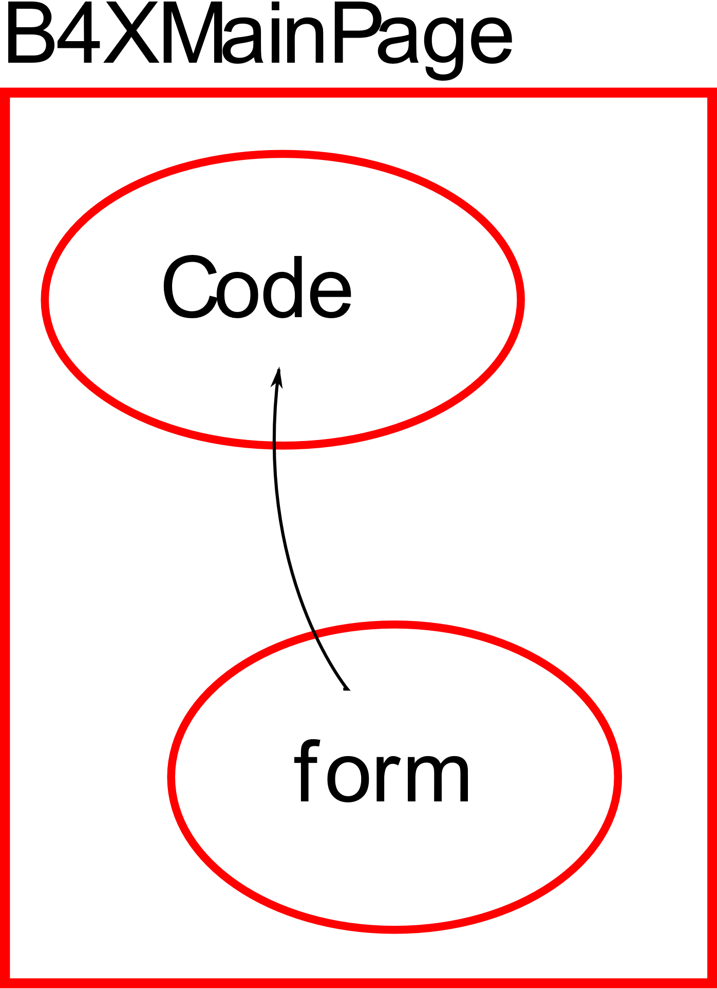B4XPages is a software library. Includes classes and procedures to create multiple application communication forms with the user. Also, it helps to transfer applications to different platforms using the B4A, B4i and B4J tools.

Every application you have created so far with B4J already includes a B4XPage. This is B4XMainPage which is always the user's first contact form with the application. More generally, each B4XPage manages all the codes required for the GUI (Graphics User Interface) to work.

## The structure of an application's folders

When you start a new program with B4XPage, the following folder structure is created.

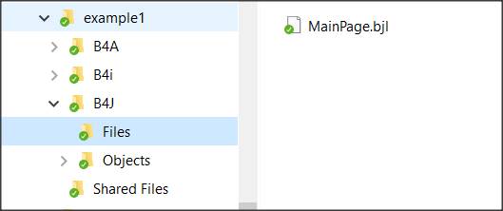Each of the three folders B4A, B4i And B4J include the relevant codes in order to create applicat **MainPage.bjl** ions, Android, Ios computers (Windows, Linux platforms) respectively.

Figure example1 folders

Specifically, in the **B4J** folder there is the “Files” folder where it contains all the files created with the Designer as well as any other files that must be used during the execution of the code e.g. images. **MainPage**.**bjl** is the file that was created automatically during the creation of the application and is its home screen. The Shared Files folder also includes files that the three different applications can share if the developer **chooses** to create an application for both Android, IOS and PC.

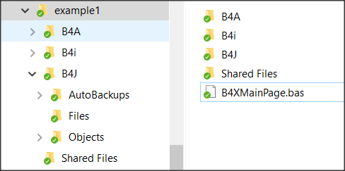The application's home folder contains all the files that create the different B4XPages of our application.

Figure B4XPage files

The first page that is created must have the name **“B4XMainPage.bas”** and cannot be changed; all other pages are named by the developer.

## Starting an application with B4XPage.

When creating a new application with B4Xpage, the language has already prepared the first page and as mentioned its name in the application folder is B4XMainPage.bas. Also, it has created a form (or GUI screen) to communicate with the user (named MainPage.bjl). Eventually, a mechanism called B4XPagesManager undertakes to manage the pages.

**Sub** Class_Globals

**Private** Root **As** **B4XView**

**Private** xui **As** **XUI**

**End Sub**

**Public Sub** Initialize

**End Sub**

**Private Sub** B4XPage_Created (Root1  **As**  **B4XView**)

Root = Root1

Root. LoadLayout("MainPage")

**End Sub**

### What is Root

The Root variable is an object of class B4XView. Undertakes to perform all display-related tasks in the various forms created by the developer (also associated with code sharing in B4J, B4A, B4i). Therefore, the Root object instructs the MainPage form to load with the Root.LoadLayout("MainPage" method).

### Create a new B4XPage

**Step 1.**

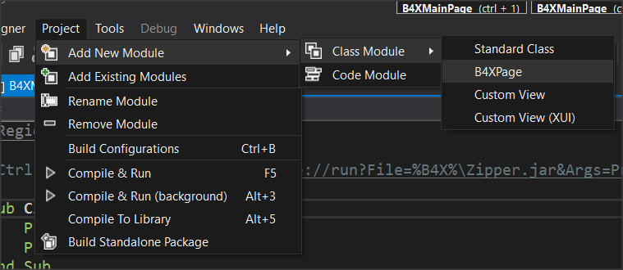After Create an app select from the menu Project – Add New Module – Class Module – B4XPage And Give the name B4XPage1.

Picture Create B4XPage

## 

A class with a name “B4XPage1” will be created, and some necessary codes to get started. The user communication screen (GUI) has not yet been created at this point. This should be done by the Designer later.

**Sub** Class_Globals

**Private** Root  **As**  **B4XView** 'ignore

**Private** xui  **As**  **XUI** 'ignore

**End Sub**

'You can add more parameters here.

**Public Sub** Initialize  **As**  **Object**

**Return Me**

**End Sub**

**Private Sub** B4XPage_Created (Root1  **As**  **B4XView**)

Root = Root1

'load the layout to Root

**End Sub**

Picture The new B4XPage

**Step 2.**

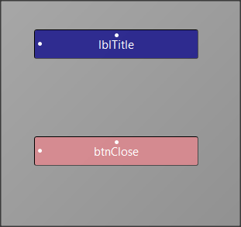Open Designer and from the menu File select New.

Picture Form

From the Variants tab, specify the dimensions of the form you want to design, and then select a label and button to insert into your form as in the Picture 24.

**Step 3.**

Use the menu Generate Members to insert the two objects into your code as well as the Click of the button. Remember that this action must be applied when you are in the code of the B4XPage1.

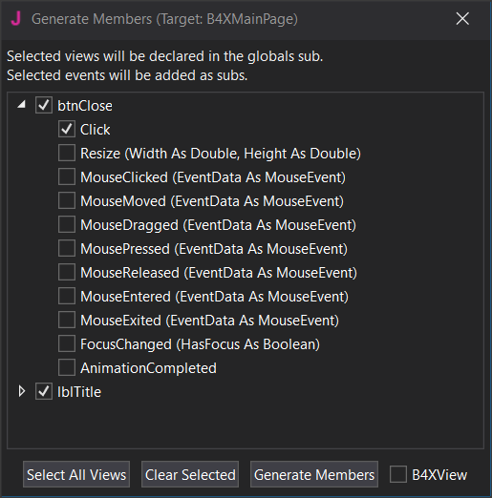

Picture Generate Members

From the file menu save your form named frmPage1. (You can give any name you want, and it serves the needs of the application).

The following code (Picture 26) will now be created, and the file will have been displayed frmPage1.bjl in the folder files.

Picture frmPage1

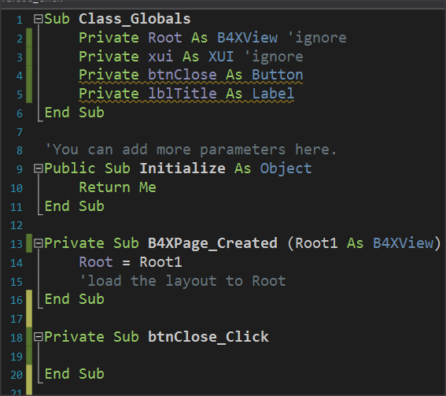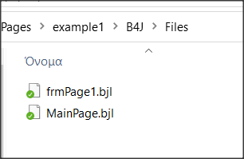

**Step 4.**

To link the form frmPage1 with the B4XPage1 you must now call the property Root.LoadLayout("frmPage1") within the event B4XPage_Created.

**Private Sub** B4XPage_Created (Root1  **As**  **B4XView**)

Root = Root1

'load the layout to Root

Root.LoadLayout(“frmPage1”)

**End Sub**

The next steps include method’s programming and depend on the purpose of the application you are building.

In our example, suppose you want to move to the B4XPage1 screen with one click in B4XmainPage’s button and then click the button you placed to return to the home page.

## Call a new B4Xpage.

Each new B4XPage you create is a class. Therefore, before you can use it, you must create an object based on it. The creation is usually done in the B4XPage that will call the new one. So, in the previous example we write in B4XmainPage (Picture 27):

1. 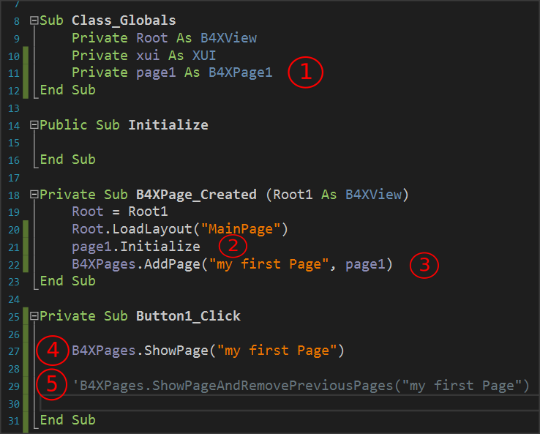Set a class object B4XPage1.

Picture Create B4XPage

1. Initialize page 1. Runs the Initialize routine within class B4XPage1.
2. Create an ID for the new page object. (In the example is "my first Page")
3. Call the new page while the home page remains open.
4. Second way to call a page where the home screen closes and only the new page remains open.

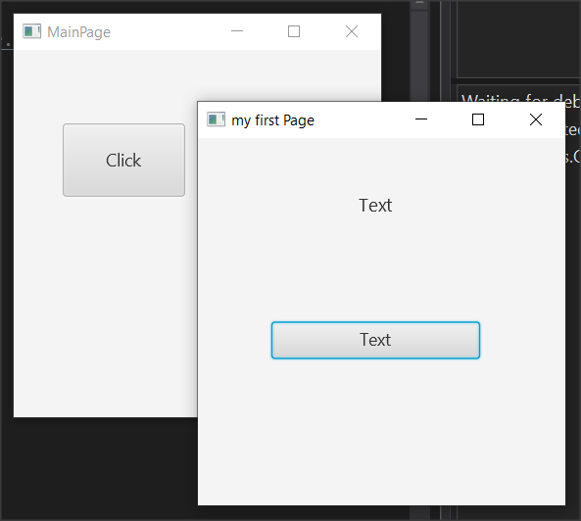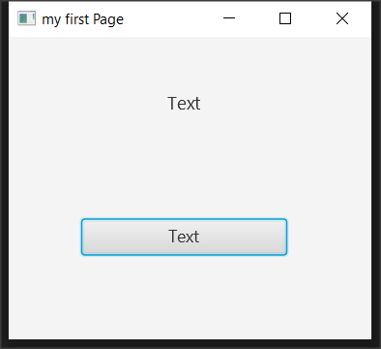

Picture 28 Two methods to open a B4Xpage

## Close a B4XPage.

When a B4XPage is called, the program control passes to that page. Therefore, for the page to close, an event must occur, such as pressing a button or the close button in the top right of the window. More generally, it also depends on how the screen was opened:

|  |  |
| --- | --- |
| **When opened with:** | **Usually closes with:** |
| B4XPages.ShowPage("my first Page") | B4XPages.ClosePage(Me) |
| B4XPages.ShowPageAndRemovePreviousPages("my first Page") | B4XPages.ShowPageAndRemovePreviousPages("MainPage") |

The first way closes the current form while the second way essentially calls the home page again while closing the current one.

## Transfer information between pages

For one page to have access to data from another, those pages must have variables declared with the keyword Public. The pages objects themselves when they are created either in the MainPage or elsewhere have also been declared as Public.

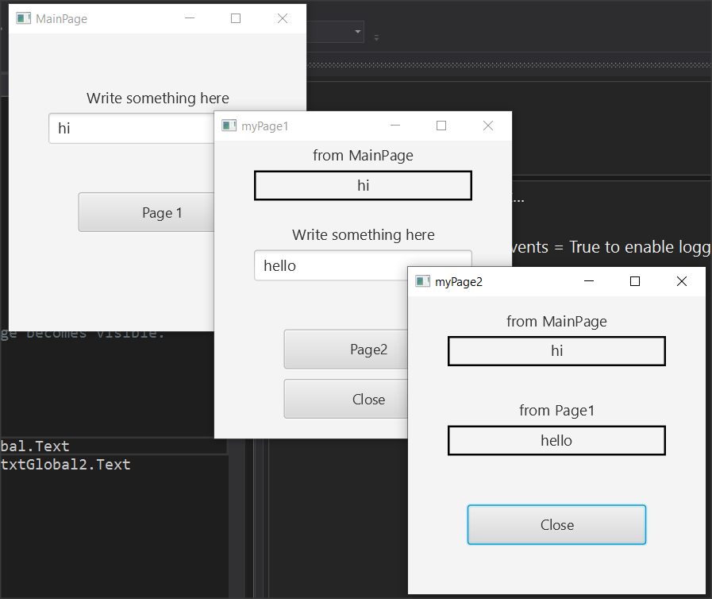

Picture Example 2

**Example 2**

For the purposes of this example, you will use the application of example 2. This includes MainPage, B4XPage1 and B4XPage2. Forms have also been created in the Designer. Open example 2, run it, and observe its operation.



As you run the application, notice that text from textFields is transferred to the following pages. This is because both page1 and page2 and both TextField are declared public.

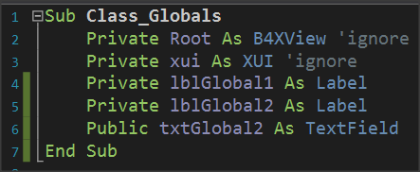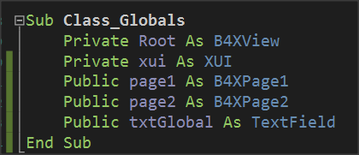

Picture 30 Public declarations in MainPage and Page1

In order page1 to have access to the txtGlobal1 variable, it must also use it by indicating the name of the page on which it was created:

lblGlobal1.Text = **B4XPages.MainPage**.txtGlobal.Text

where lblGlobal1 is a label that displays the content read on the page1 screen.

Similarly, Page2 has access to MainPage's txtGlobal1 and Page1's txtGlobal2 variables as follows:

lblGlobal1.Text = **B4XPages.MainPage**.txtGlobal.Text

lblGlobal2.Text = **B4XPages.MainPage.page1**.txtGlobal2.Text

where lblGlobal1 and lblGlobal2 are two labels that display the contents of the two Public Variables on the page2 screen.

## The Life of B4XPages

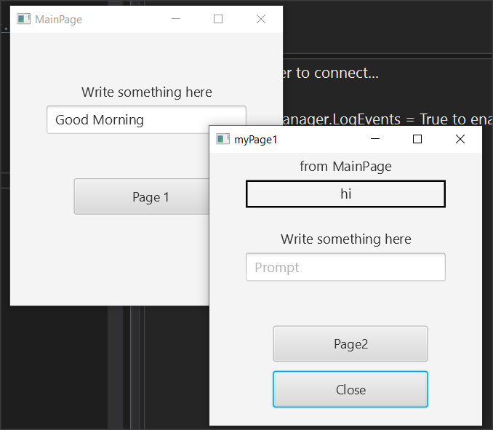In the previous example, try closing all windows except MainPage and type in new text and press the button to page1. You will notice that the value displayed by the MainPage it is not the new but still shows the first one.

Picture B4XPage life

This is because B4Xpages remain in computer memory and each time they are called the event B4XPage_Create does not run again. To read the global variables again from MainPage you can run event **B4XPage_Appear** and in there use the variables from MainPage:

**Private Sub B4XPage_Appear**

lblGlobal1.Text = B4XPages.MainPage.txtGlobal.Text

**End Sub**

Unlike B4XPage_Create that runs only once on the first call of the page, B4XPage_Appear runs every time the window appears in the foreground, so you can use it whenever the page returns to transfer variables from other forms.

## Exercises

1. The little encyclopedia of dogs. Create an application where three different breeds of dogs are displayed on a home page and after the user clicks on the corresponding name display information about the breed along with two photos.

*You can use TextArea in designer to make bigger text areas with scroll bar.*

1. Build an application that solves:
   1. the primary equation ax+b=0,
   2. the secondary equation ax a2+bx+c=0 and
   3. calculates the hypotenuse of a triangle given the dimensions of the two vertical sides.

*It is given that the square root of an x number is calculated by sqrt(x).*

1. 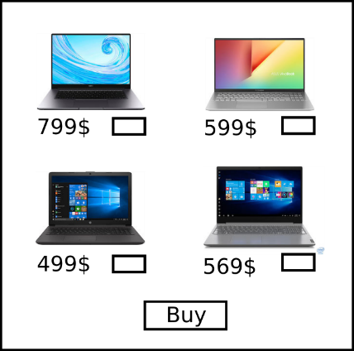Build an app that creates a virtual store as follows: The home screen will show images of 4 different objects, such as laptops and a TextField for each item where customer writes the quantity. Then pressing the Buy button, the program on a new page displays the Total Value and quantity of items selected. *Except MainPage you will need only one more.*